 |  | 
LEIBNIZ INSTITUT FÜR ASTROPHYSIK POTSDAM | INSTITUT FÜR SONNENPHYSIK | MAX PLANCK INSTITUT FÜR SONNENSYSTEM-FORSCHUNG

GREGOR:
DOME AND TELESCOPE MAINTENANCE

Document No.: | GRE-KIS-MAN-0029
Version: | 1
Date: | 10.04.2025

Signatures & Approval
 |  | Name | Signature |  | Date
Prepared by |  | Miguel Esteves - KIS  Mechanical Engineer |  | 10.04.2025
Reviewed by
Approved by |  | Reiner Volkmer  (Technical Manager) |  | 26.5.2025
Released by

Change Log
Version | Date | Author | Reason for Change
1 | 10.04.2025 | M. Esteves | New Document

Change Record
Version | Description of Changes | Paragraph | Pages
1 | New document

Table of Contents
1 SCOPE 4
2 MATERIAL NEEDED 4
3 DOME MAINTENANCE 5
3.1 Main Frame Mechanism (Bows) 5
3.1.1 Spindles 5
3.1.2 Fork head central bushes 6
3.1.3 Fork head lateral bushes 6
3.1.4 Swivel flange bush 6
3.1.5 Swivel flange washer 7
3.1.6 Motors and Gearboxes 7
3.1.7 Worm gear 8
3.1.8 Opening bearings 9
3.1.9 Bearing between the sheets or panels 10
3.1.10 Rod end between the sheets or panels 10
3.2 Clamping mechanism (Jaws) 11
3.2.1 Spindles 11
3.2.2 Guiding rollers 13
3.2.3 Gearmotor 14
3.2.4 Worm gear 14
3.2.5 Mechanism guideways 15
3.2.6 Spindle nut bushings 15
3.2.7 Swivel flange bushings 16
3.2.8 Swivel flange washers 16
3.2.9 Ball bearing at the spindle end 17
3.2.10 Bushes for worm gear swivel 17
4 TELESCOPE MAINTENANCE 18
4.1 Azimuth (AZ) 18
4.1.1 Crown Gear 18
4.1.2 Bearings 19
4.1.3 Drives (x2) 19
4.1.4 End switch 20
4.2 Elevation (EL) 21
4.2.1 Crown Gear 21
4.2.2 Bearings 22
4.2.3 Drives (x2) 23
4.2.4 End switch 24
5 Miscelaneus 24
5.1 Azimuth and Elevation Locking pin units 24
5.2 Coude entrance cover 25
5.3 M1 cover 26
6 Checklist 27

SCOPE

This document shows the procedure concerning the dome and the telescope maintenance, which shall be programmed every year or every two as much, except for the screw jack spindles from the clamping mechanism, which might require a service with a periodicity even shorter than yearly (See section 3.2.1).
The maintenance here shown refers only to mechanical maintenance, i.e., lubrification of the mechanisms. For those parts to be service with a greasing gun, two or three shots are enough.
Only the sections highlighted in yellow require maintenance. The rest of the points are mentioned here for completeness of the report, as they contain valuable information concerning the mechanisms and the commercial references for the standard components.
Two people are needed to perform the task, and it can take between half or a full day as much.
Good weather is needed for at least some of the operations, which require having the dome opened.
A printable checklist can be found on the last section of the report.

MATERIAL NEEDED

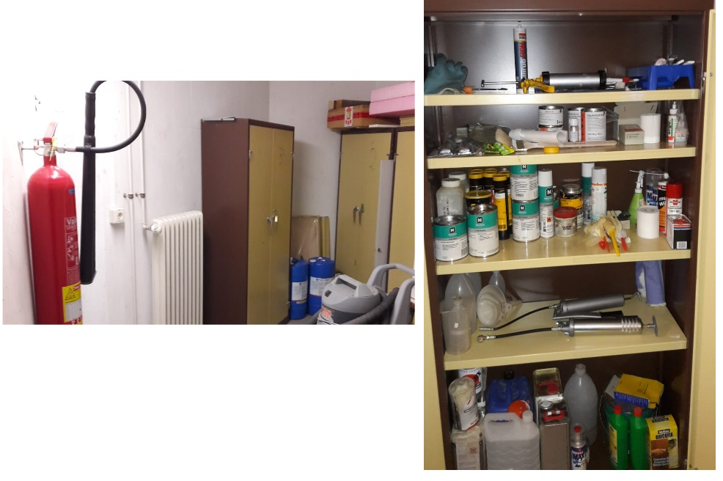
Almost everything which is needed to do the maintenance (grease, brushes, grease pump guns, paper, gloves, etc.) can be found at the telescope basement (metallic cabinet shown). A toolbox from the optics lab will be also needed.
Fig. 1: Material location at Gregor basement.
There are two grease pumps guns: One is used for the dome and other for the telescope, attending to the greasing point shape.

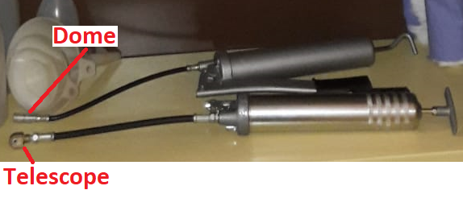
Fig. 2: Grease pump guns at Gregor basement.

The greasing point connector can be exchanged from one gun to the other.
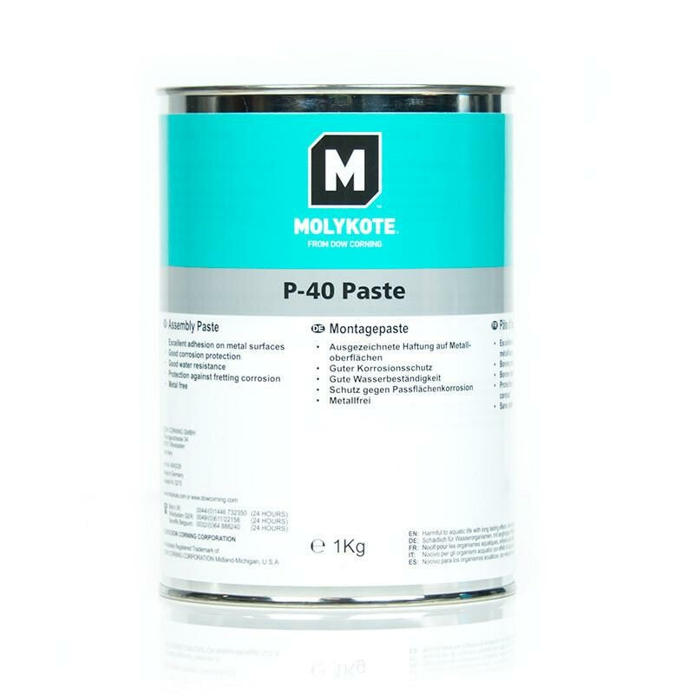

DOME MAINTENANCE

Main Frame Mechanism (Bows)

Spindles

Component type: Screw jack spindle (x4)

Grease: Molykote P40. Applied with a brush.

Procedure: Open the dome. Remove the dust protector from the upper and the lower side of the spindle. For the lower side, the motor transparent covers have to be removed. Take the chance when the covers are out to also do section 2.2.7.

Once finished, close and open the dome a few times to spread the grease along the spindle.

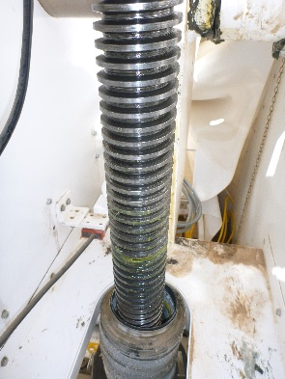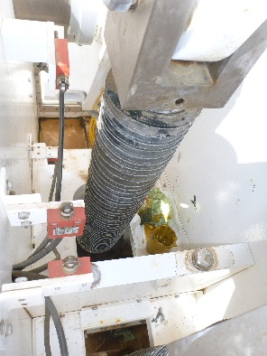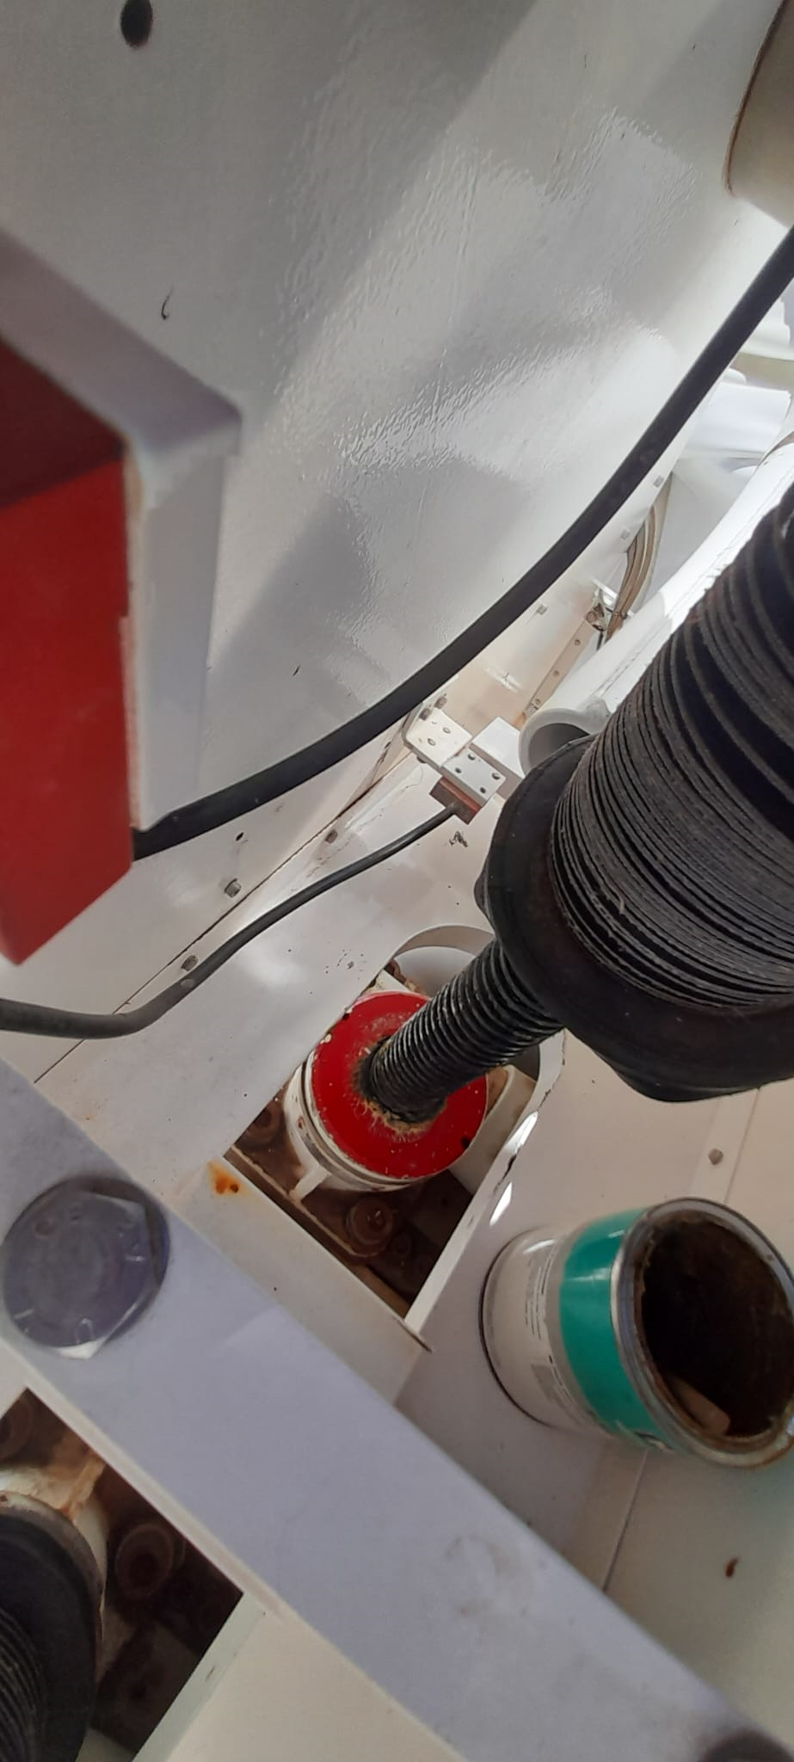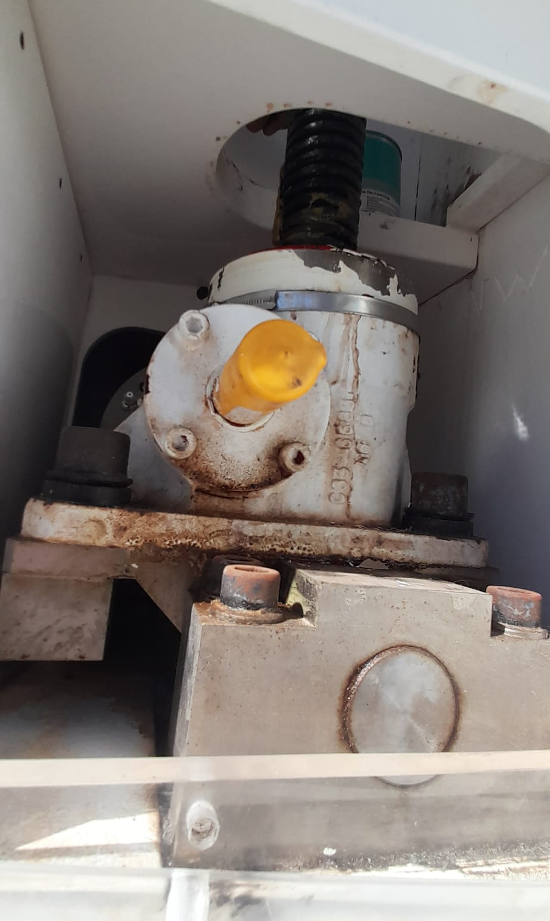

Fig. 3: Spindles with dust protector removed. Left and central left: Protector removed from the upper side. Right and central right: Protector removed from the lower side.

Fork head central bushes

Component type: Spherical plain bearing bushes.

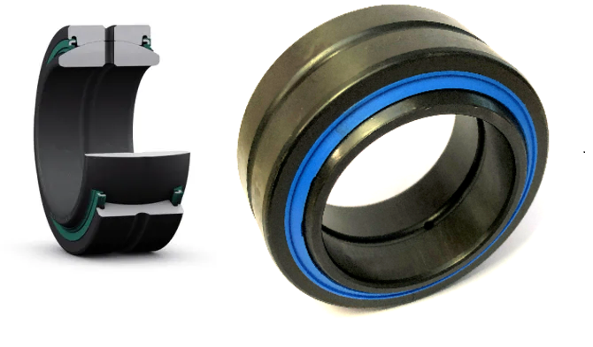
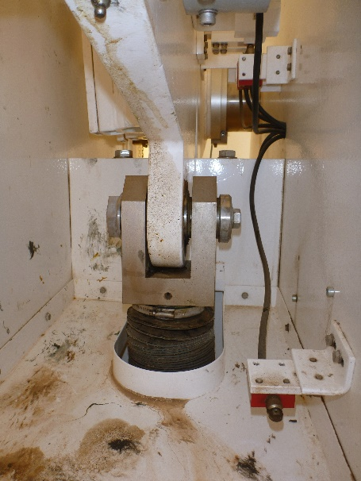
Fig. 4: Fork head central bushes images (right) and location (left).

Manufacturer - Type: SKF GE 50 TE-2RS [Maintenance-free spherical plain bearing with sliding contact surface combination steel/PTFE fabric]
Grease: Self Lubricating.

Fork head lateral bushes

Component type: Plain bearing bushes

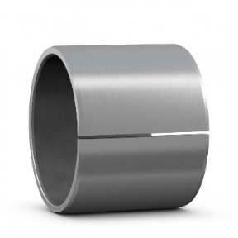
Manufacturer - Type: SKF PCM 556030 M [Composite dry sliding bushing]
Grease: Self Lubricating

Fig. 5: Fork head lateral bushes image (right) and location (left).

Swivel flange bush
Component type: Plain bearing bush.

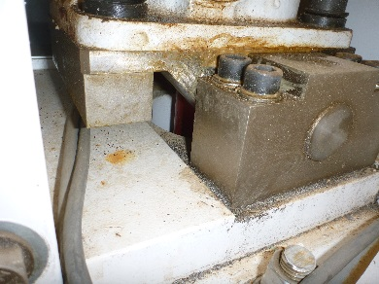
Manufacturer - Type: SKF PCM 505540 M [Composite dry sliding bushing]
Grease: Self Lubricating
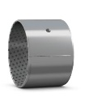

Fig. 6: Swivel flange bushes. Location (left). Image (right).

Swivel flange washer

Component type: Lateral guide washer

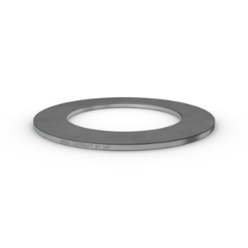

Fig. 7: Swivel flange washer. Location (left). Image (right).

Manufacturer – Type: SKF PCMW 527802 M [Composite dry sliding thrust washers]
Grease: Self-Lubricating.

Motors and Gearboxes

Component type: Main drives motors and gearboxes (x4)

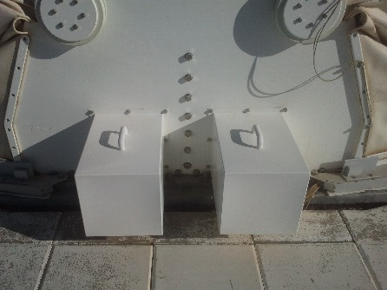

Fig. 8: Dome main drive motors and gear locations under the housing.
North side (x2) and south side (x2).
Manufacturer: ABM G112F/4D100Lc-4 (3kW, 145 rpm) [Gearbox: 2 stages helical box; Drive: 4 pole & 3 phases]
Grease: This kind of motors are lubricated for the first 10.000 operating hours for the case of gear oil model, and for 8.000 operating hours for the grease model. Given the high numbers compared to the low running effective time at the telescope, no greasing/oiling is needed unless because of ageing.

Worm gear

Component type: Worm gear (x4)
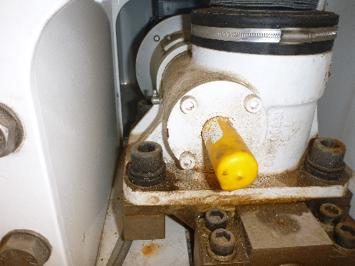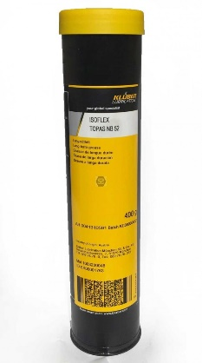

Fig. 9: Grease nipple and location.
Manufacturer: Power Jacks / Duff N.; i=8:1; Pitch:12 mm; Typ: TE 1820-800
Grease: What Manufacturer recommends is:

“For normal operation, the screw jacks should be lubricated about once a month, using one of the following extreme pressure greases, or their equivalent:

Shell: Gadus S2V22OAC2 (Alvania WR2)
BP: Energrease LC2
Castrol: Spheerol EPL2
Mobil: Mobilux EP2”

Note: Isoflex TOPAS NB 52, Klüber, has been used since 2021 campaign. According to Klüber, it has good load-carrying capacity.
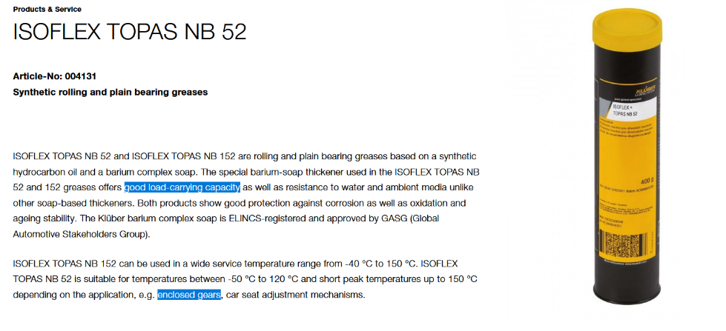
Procedure: Open the plastic covers to be able to access the greasing point.

Opening bearings

Component type: Spherical plain bearing

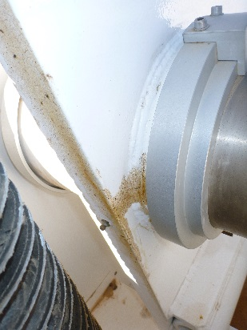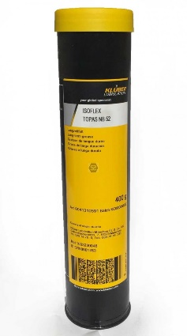

Fig. 10: Grease nipple location and type of grease

Manufacturer: SKF GE 120 ES [Radial spherical plain bearings requiring maintenance]
Material: Steel-on-steel
Grease: SKF grease LGHB 2 (Recommended by SKF).

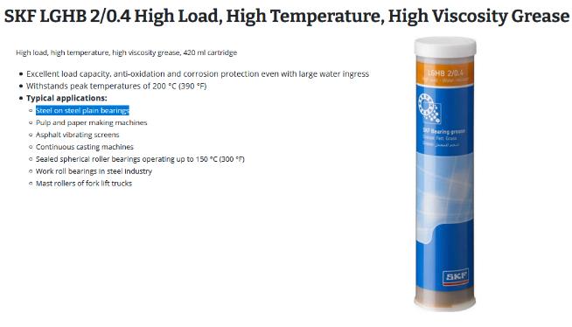
Note: Isoflex TOPAS NB 52 from Klüber was used in 2021 campaign.

Bearing between the sheets or panels

Component type: Spherical plain radial bearing.

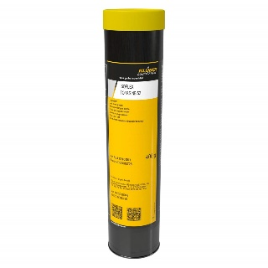
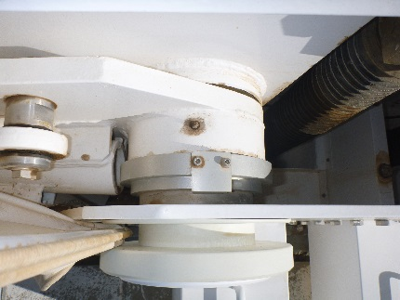

Fig. 11: Grease nipple location (left) and type of grease (right).
Manufacturer: SKF GE120 ES [Radial spherical plain bearings requiring maintenance]
Material: Steel-on-steel
Grease: SKF grease LGHB 2 (Recommended by SKF).
Note: Isoflex TOPAS NB 52 from Klüber was used from 2021 campaign on.

Rod end between the sheets or panels

Component type: Rod end

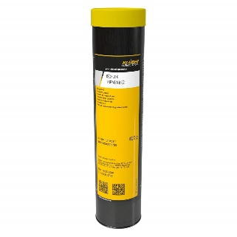

Fig. 12: Grease nipple location and type of grease.
Manufacturer: SKF SC 40 ES [Rod end requiring maintenance, steel on steel, welding shank]
Material: Steel-on-steel
Grease: SKF grease LGMT 3 (Recommended by SKF).
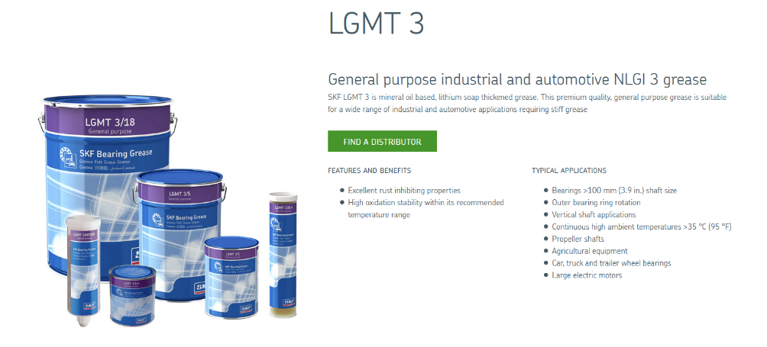

Note: Isoflex TOPAS NB 52 from Klüber was used from 2021 campaign on.

Clamping mechanism (Jaws)

Spindles

Component type: Screw jack spindle (x2)

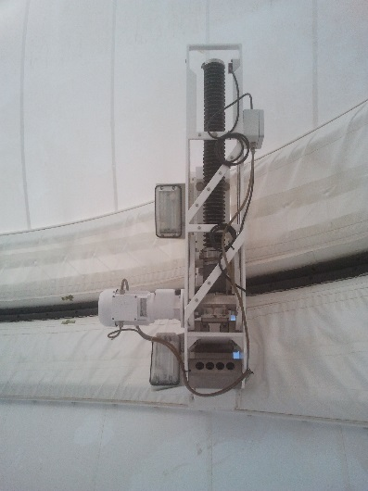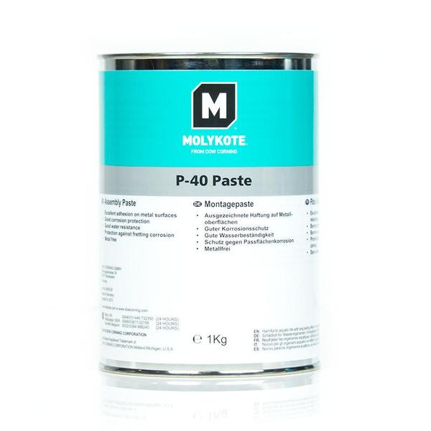

Fig. 13: Screw jack spindle for the clamping mechanism.

Grease: Molykote DX.
Note: In the past, it was serviced with Molykote P40, like with the bows spindles, but after replacing the original textile, perhaps they are now smaller in size or have different mechanical properties, for this reason the mechanical tension is higher and as a result of it, the spindle was returning once the dome was closed. Molykote DX has better properties in this case and the spindle doesn’t come back when it is applied. Whenever the spindle shows this behavior, please open and apply DX on them.

Procedure: Open the dome. As the mechanism is fully opened when the dome is folded down, do the lower side from the spindle by removing the lower dust protection and apply the grease with a brush. Close the protection and manually move the mechanism (close and open) several times (See procedure below on how to operate the mechanism manually).
Repeat the process for the upper side of the spindle. In this case, the starting point from the mechanism should be closed, so that the upper dust protection can be removed.

Procedure to move the Jaw’s spindle manually:

- Open the dome control box at the dome side (Box where the HHP to operate the dome is hanged to). The default setup is shown below:
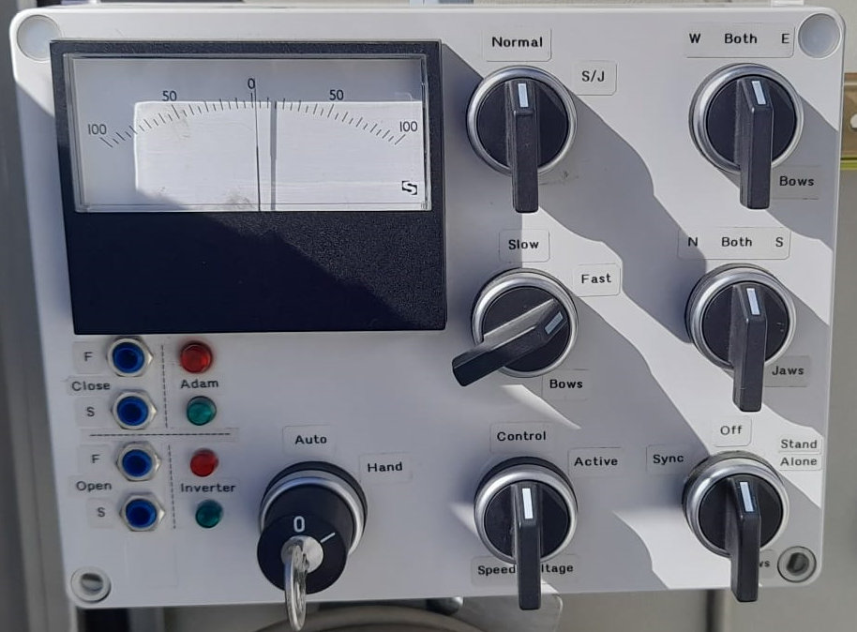

Fig. 14: Dome control box. Default configuration.

- To move the jaw’s spindle: Turn the key to manual mode, normal to S/J, Jaw’s knob to the desired side, so as to move one spindle each time, stand-alone from the bottom right knob and, lastly, move speed voltage to active. Then, press the open or close bottom from the HHP.

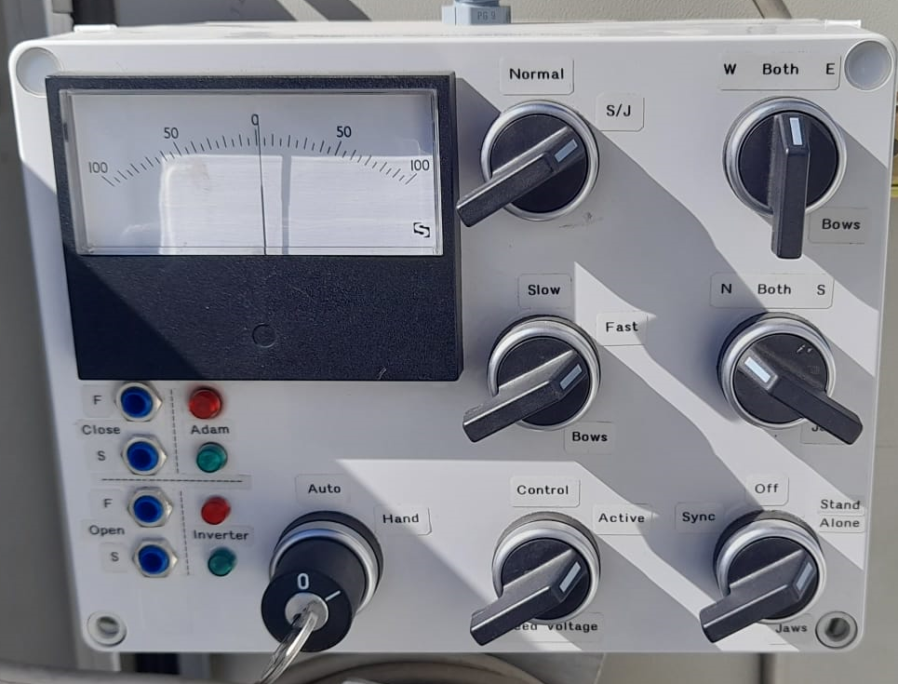

Fig. 15: Dome control box. Configuration setup for moving the jaws spindles manually.

Guiding rollers

Component type: Rollers

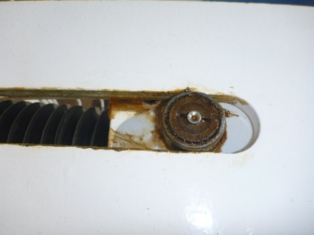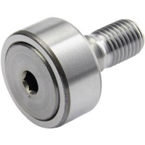

Fig. 16: Grease nipple location (left) and type of grease (right).

Manufacturer: SKF A2NIP KRV 35 PP (with the axis 18 mm wide, M16x1.5, protective cover) [Cam Follower]
Grease: SKF grease LGWA 2 (Recommended by SKF).
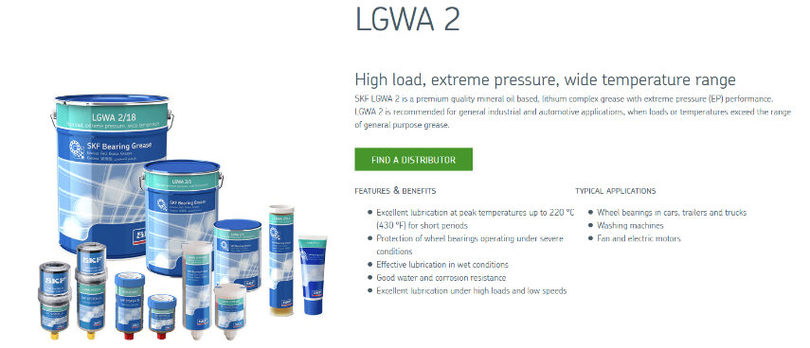

Until 2025 they haven’t been serviced, due to the low running time in comparison to other industrial applications. Molykote P40 could be compatible. KIS will procure a proper greasing gung or accessory for this kind of nipples.

Gearmotor

Component type: Gearmotor (x2)

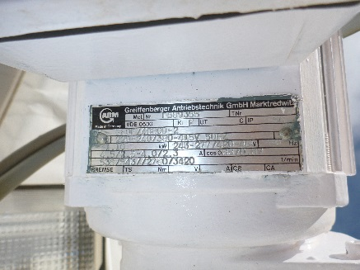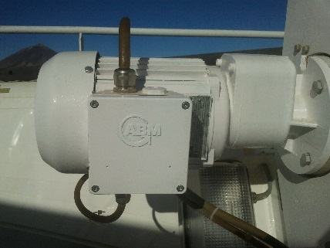

Fig. 17: Gearmotor. Note that these gearmotors were completely renovated by two new equivalent units in 2024.

Manufacturer: ABM G80F/4D80b-2 (1.1 kW, 536 rpm) [Gearbox: 2 stages helical box; Drive: 2 pole & 3 phases]
Grease: This kind of motors are lubricated for the first 10.000 operating hours for the case of gear oil model, and for 8.000 operating hours for the grease model. Unless because of ageing, there is no reason for doing maintenance.

Worm gear

Component type: Worm gear.

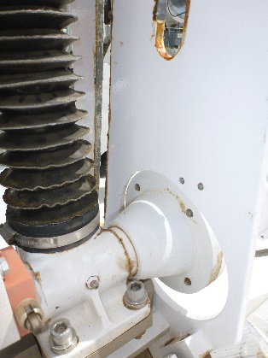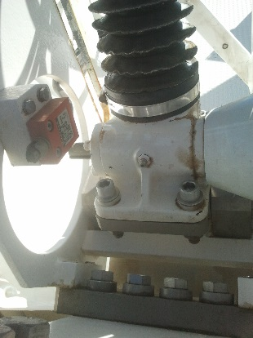

Fig. 18: Worm gear. Grease nipple location (left) and type of grease (right).

Manufacturer: Power Jacks / Duff Norton, i=6:1, Typ: UE 1803-920 (UM 1803 has .250 pitch)
Grease: What Manufacturer recommends is:

“For normal operation, the screw jacks should be lubricated about once a month, using one of the following extreme pressure greases or their equivalent:
Shell: Gadus S2V22OAC2 (Alvania WR2)
BP: Energrease LC2
Castrol: Spheerol EPL2
Mobil: Mobilux EP2”

Note: Isoflex TOPAS NB 52 from Klüber was used from 2021 campaign on.

Mechanism guideways

Component type: Guideway

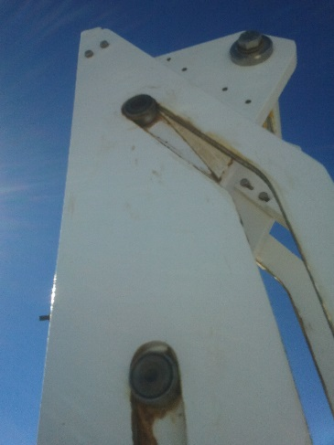

Fig. 19: Guideways (left) ad type of grease (right).

Grease: Molykote P40. Apply it with a brush or finger (using gloves). Only a tiny bit, remove the excess from the sides.

Spindle nut bushings

Component type: Dry sliding flanged bushings
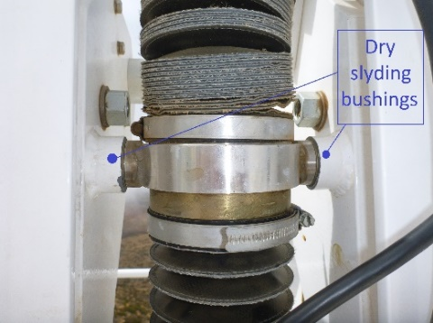

Fig. 20: Spindle nut bushings locations

Manufacturer: SKF PCMF 202321.5 B [Composite dry sliding flanged bushing]
Grease: Self-Lubricating

Swivel flange bushings

Component type: Dry sliding bushing

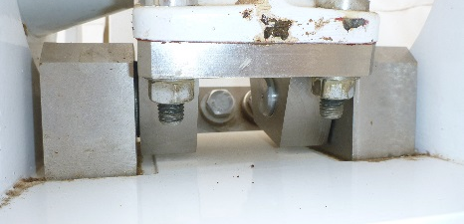

Fig. 21: Swivel flanges bushings location.

Manufacturer: SKF PCM 252830 M [Composite dry bushing]
Grease: Self-Lubricating

Swivel flange washers

Component type: Dry sliding washer
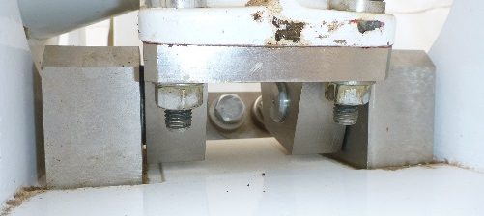

Fig. 22: Swivel flanges washers location.

Manufacturer: SKF PCMW 264401.5 M [Composite dry sliding thrust washer]
Grease: Self-Lubricating

Ball bearing at the spindle end

Component type: Ball bearing holding the dust cover at the spindle end regardless the rotation.
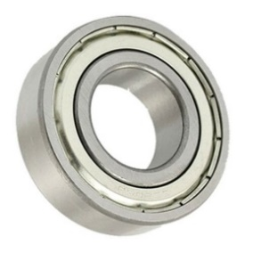
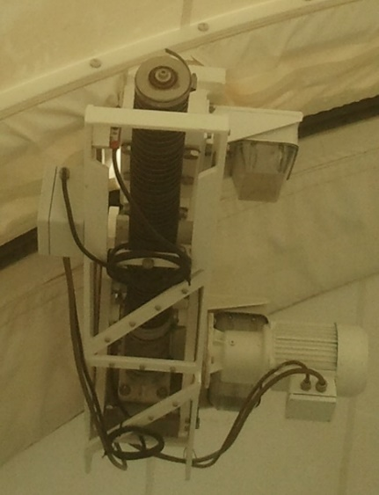
Fig. 23: Ball bearing at spindle end. Location (left) and image (right).

Manufacturer: SKF 3204 A-2Z [Angular contact ball bearing, double row]
Grease: No maintenance specified by the manufacturer.

Bushes for worm gear swivel
Component type: Dry sliding bushing

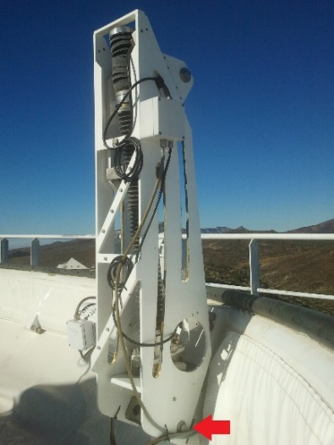

Fig. 24: Bushes for worm gear swivel location.

Manufacturer: SKF PCM 404420 M [Composite dry sliding bushing]
Grease: No grease needed

TELESCOPE MAINTENANCE

Azimuth (AZ)

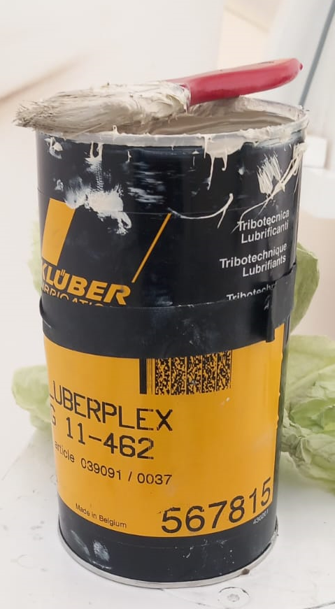
Crown Gear

Component type: Crown gear
Grease: Klüberplex AG 11-462 from Klüber. Applied with a brush.
Procedure: There are two covers located on the AZ platform giving direct access to the teeth. Open both of them. Take care to clean with a vacuum machine before opening to avoid dust falling on the teeth.
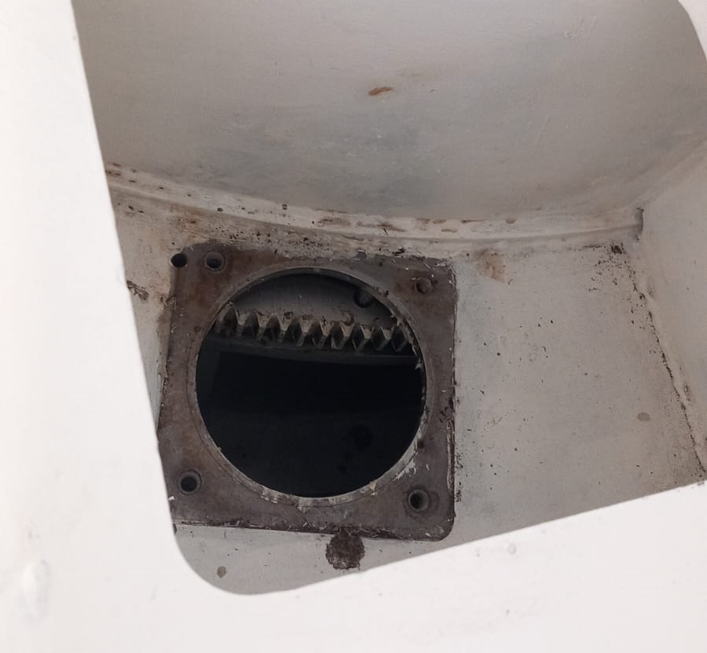
Fig. 25: AZ crown. There are two access on the AZ platform.

Take the grease and the brush to apply it. A second person can move manually the telescope along the crown. The telescope shall be moved 180° (a few degrees more), then move yourself to the second access and take the telescope back to the parking position. Then the entire crown would be covered.
Please, position yourself as shown below to avoid any danger in case the telescope is moved accidentally in elevation. A good practice could be to also put the EL stow pin in.
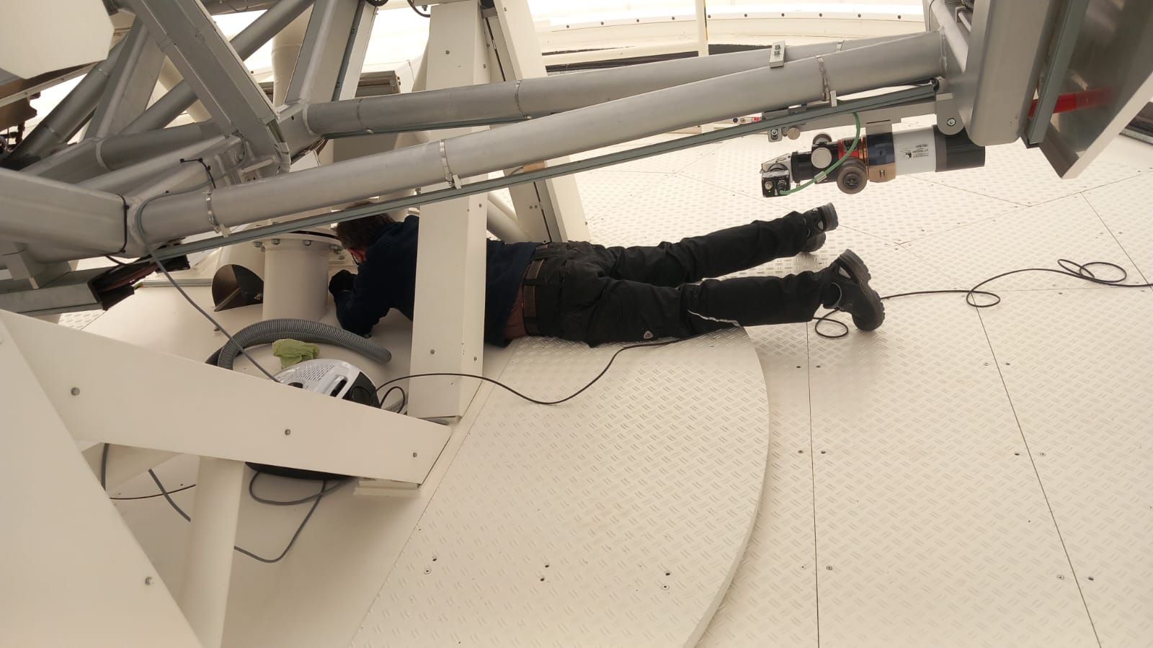
Fig. 26: Positioning for the person applying the grease, which is secure in case the telescope is accidentally move in EL. If possible, insert also the EL stow pin for more security.

Bearings
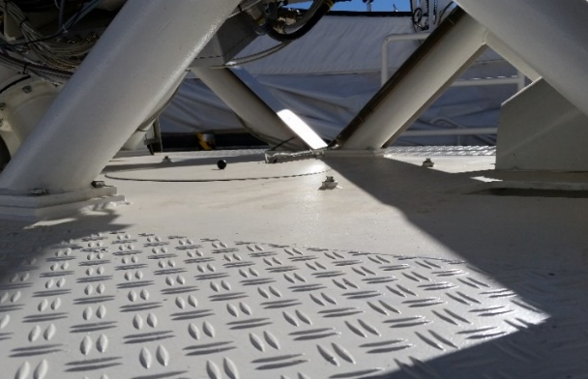
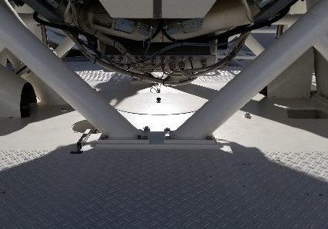

Fig. 27: AZ bearings. Greasing points (x6).

MAN Drawing number: 163453-3122-01-00
Drawing comments: “Clean well and fill with grease Klüber isoflex NB 52”
Manufacturer - Type: SKF
Grease: Klüber isoflex NB 52

Drives (x2)

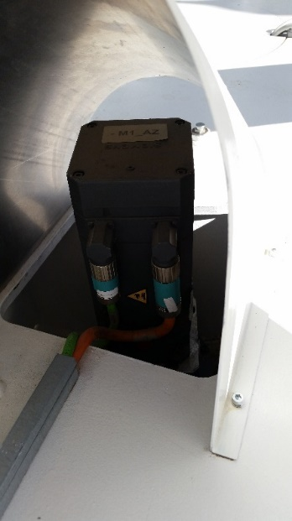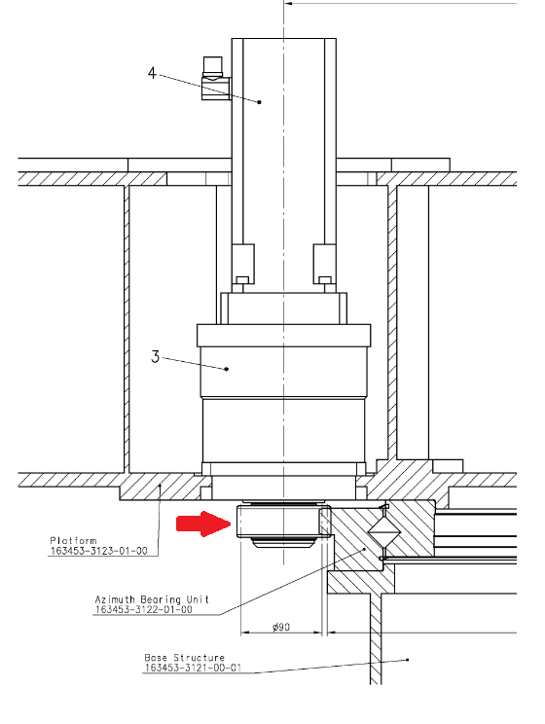

Fig. 28: AZ Drives location and drawing section view.

MAN Drawing number: 163453-3122-02-00
Drawing comments: “Gear to be coated with dry lubricant Klüber Unimoly C220 5…15µm”
Manufacturer - Type:
  - Servo: 1FT6062-6AC7-EL5 (Siemens)
  - Gearbox: SP180-MC-16-261-000 (Alpha)
  - Gear: Unknown
Grease:
  - Servo & Gearbox: Lifetime lubrication
  - Gear: Klüber Unimoly C220 5…15µm

End switch

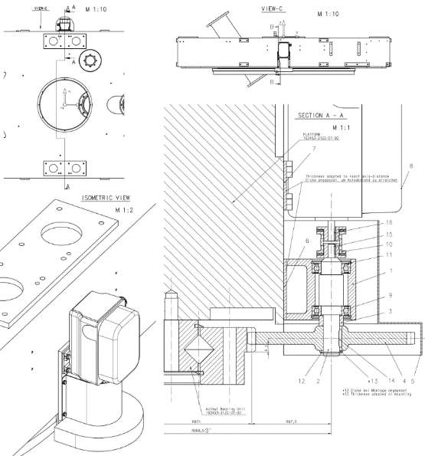

Fig. 29: End switch drawing details.

MAN Drawing number: 163453-3122-04-00
Drawing comments: “Gear to be coated with dry lubricant Molykote 3402C”
Manufacturer - Type:
  - Internal bearing: 6005 2RSR FAG
  - Gear: Unknown
Grease:
  - Internal bearing: Lifetime lubrication
  - Gear: Molykote 3402C

Elevation (EL)

Crown Gear

Component type: Crown gear
Grease: Klüberplex AG 11-462 from Klüber.
Procedure: The teeth are accessible from the lateral side of the telescope. Apply the grease with a brush.
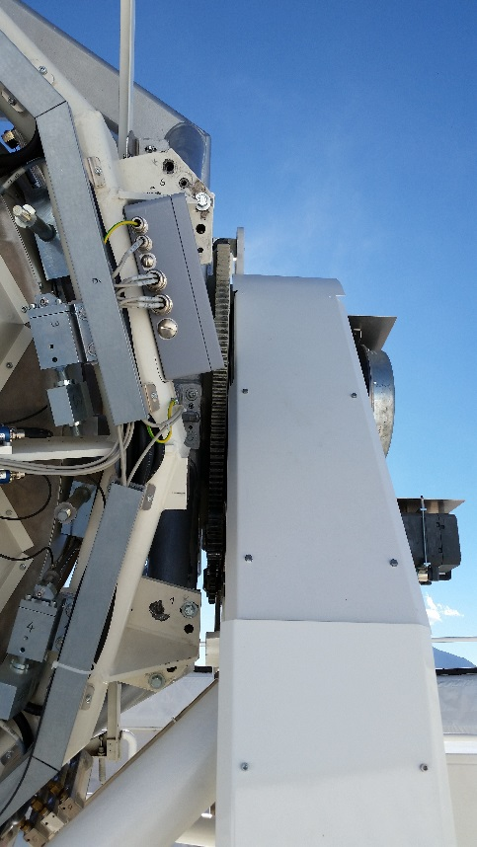
Fig. 30: EL crown location.

Bearings

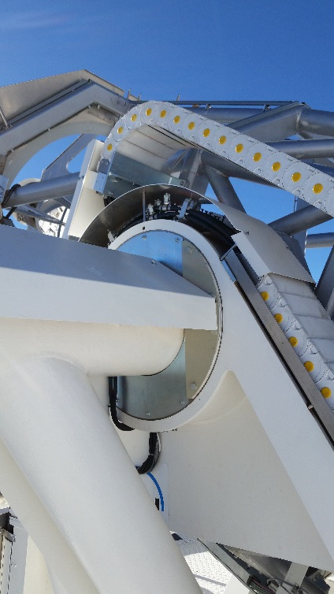

Fig. 31: EL bearings. Greasing points (x4).

MAN Drawing number: 163453-3124-01-00
Drawing comments: “Clean well and fill with grease Klüber isoflex NB 52 G 395 before assembling”
Manufacturer - Type: SKF
Grease: Klüber isoflex NB 52 G 395

Drives (x2)

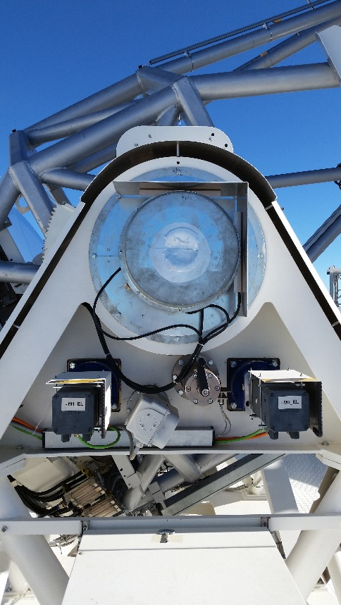

Fig. 32: EL Drives location on a lateral side from the telescope.

MAN Drawing number: 163453-3124-02-00
Drawing comments: “Gear to be coated with dry lubricant Molykote 3402 C”
Manufacturer - Type:
  - Servo: 1FT6062-6AC7-EL5 (Siemens)
  - Gearbox: SP180-MC-16-261-000 (Alpha)
  - Gear: Unknown
Grease:
  - Servo & Gearbox: Lifetime lubrication
  - Gear: Molykote 3402 C

End switch

Fig. 33: EL End switch.

MAN Drawing number: 163453-3124-05-00
Drawing comments: “Gear to be coated with dry lubricant Molykote 3402C”
Manufacturer - Type:
  - Internal bearing: 6005 2RSR FAG
  - Gear: Unknown
Grease:
  - Internal bearing: Lifetime lubrication
  - Gear: Molykote 3402C

Miscelaneus

Azimuth and Elevation Locking pin units

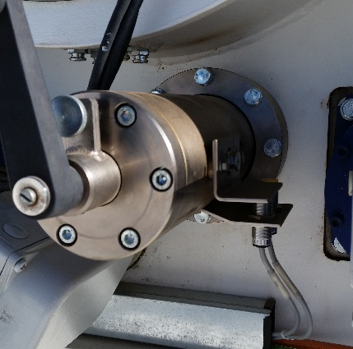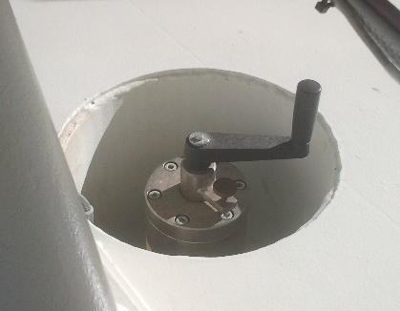

Fig. 34: Elevation (left) and azimuth (right) locking pin units.

MAN Drawing number: 163453 -3122-03-00 & -3124-03-00
Manufacturer - Type:
  - Internal bearing: QJ205-MPA FAG
Manufacturer coments: "Lubrication: They are not greased but can be lubricated with grease or oil if desired”

Coude entrance cover
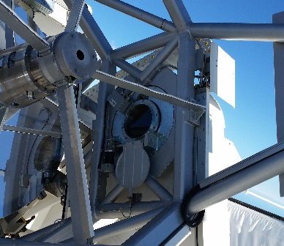

Fig. 35: Coude entrance cover mechanism.

MAN Drawing number: 163453 -3125-03-00
Manufacturer - Type:
  - Motor: Lenze – SSN31 1PHAR -045C21
  - Gearbox: Lenze – SSN31 1FHAR -0415
Manufacturer coments: No information about lubrication. Other similar motors & gearboxes from Lenze are lubricated for lifetime

M1 cover

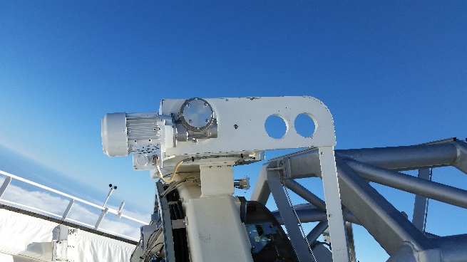

Fig. 36: M1 cover.

MAN Drawing number: 163453 -3115-01-00
Manufacturer - Type:
  - Motor: Walther Flender AS.MOT 7AAJB 63M-04
  - Gearbox: Walther Flender I40FP 100/1
Manufacturer coments:
  - Motor: “The motors of the construction group 56 to 160 are equipped with closed bearing and therefore cannot be re-lubricated. For this reason, these bearings must be replaced after the fatigue service life or grease service life expires”.
  - Gearbox: Lifetime lubricated
Grease: No greasing expected

Checklist

