|  |  |  |
| --- | --- | --- |
|  | Macintosh HD:Users:kleintl:Data:Luci:daten:work:kis:logo_KISv3.0:logo_kis_rz.png | Description: logo |
| LEIBNIZ INSTITUT FÜR ASTROPHYSIK POTSDAM | LEIBNIZ-INSTITUT FÜR SONNENPHYSIK (KIS) | MAX PLANCK INSTITUT FÜR SONNENSYSTEM-FORSCHUNG |

|  |
| --- |
| **GREGOR:**  **M11M16F3 INTERFACE** |

|  |  |
| --- | --- |
| **Document No.:** | **GRE-KIS-MAN-0024** |
| **Version:** | **2** |
| **Date:** | **2023-11-15** |

|  |  |  |  |  |  |  |  |
| --- | --- | --- | --- | --- | --- | --- | --- |
| Signatures & Approval | | | | | | | |
|  |  | Name | Signature | | Date | |
| Prepared by |  | Olivier Grassin - KIS  Software engineer |  | 2023-01-12 | |
| Reviewed by |  | Lucia Kleint - Univ. of Bern  Professor |  | 2023-04-04 | |
| Approved by |  |  |  |  | |
| Released by |  |  |  |  | |

|  |  |  |  |  |
| --- | --- | --- | --- | --- |
| Change Log | | | | |
| Vers. | Date | Author | Description of Changes | Sect./Para. |
| 1 | 2023-03-02 | O. Grassin | New Document |  |
| 2 | 2023-11-15 | O.Grassin | Visitor Mirror rotation modification | 7.2, 9, 10 |

|  |  |  |  |
| --- | --- | --- | --- |
|  |  |  |  |

**Table of Contents**

[1 Scope 4](#_Toc151033323)

[2 Reference and applicable documents 4](#_Toc151033324)

[3 Overview 4](#_Toc151033325)

[4 Features 5](#_Toc151033326)

[5 Motorization location 6](#_Toc151033327)

[6 Software 7](#_Toc151033328)

[6.1 Installation 7](#_Toc151033329)

[6.2 Smart homing 8](#_Toc151033330)

[6.3 Startup and close. 9](#_Toc151033331)

[6.4 Configuration file 10](#_Toc151033332)

[6.5 Errors/Positions log 10](#_Toc151033333)

[6.6 dcpAggregator 10](#_Toc151033334)

[7 Using the interface 11](#_Toc151033335)

[7.1 MAIN 1 panel 11](#_Toc151033336)

[7.2 MAIN 2 panel 13](#_Toc151033337)

[7.3 AXES/STATUS panel 14](#_Toc151033338)

[7.4 INFO panel 17](#_Toc151033339)

[7.5 Motorization limits 17](#_Toc151033340)

[8 Technical data 18](#_Toc151033341)

[8.1 Filter wheel positions 18](#_Toc151033342)

[8.2 CoSM modules – daisy chain configuration 19](#_Toc151033343)

[9 DCP commands 20](#_Toc151033344)

[10 What’s new? 20](#_Toc151033345)

**List of Tables**

None

**List of Figures**

[Figure 1 - Loading the interface... 5](#_Toc151033346)

[Figure 2 - Layout of the AO bench at the GREGOR 5th floor - optics lab. (Mech. draft) 6](#_Toc151033347)

[Figure 3 - Complete system diagram 7](#_Toc151033348)

[Figure 4 - ICS interface – Starting the M11M16F3 interface 9](#_Toc151033349)

[Figure 5 - Main 1 panel 11](#_Toc151033350)

[Figure 6 - Beam routing (M16) 12](#_Toc151033351)

[Figure 7 - Main 2 panel 13](#_Toc151033352)

[Figure 8 - Axes/Status panels 15](#_Toc151033353)

[Figure 9 - INFO panel 17](#_Toc151033354)

[Figure 10 - CoSM modules - daisy chain configuration 19](file:///R:\Downloads\GRE-KIS-MAN-0024_v002_m11m16interface.docx#_Toc151033355)

# Scope

This document describes the M11M16F3 interface software, which is used at the GREGOR telescope during optical setups and observations.

It is integrated in the GREGOR Control System, respecting the infrastructure and communication protocols.

# Reference and applicable documents

GCS - GREGOR Control System

ICS - Instrument Control System

DCP - Device Communication Protocol

CoSM - Communication of Short Messages system

AO - Adaptive Optics

VI - Virtual Instrument

* AO bench optical setup documentation
* M11M16F3 DCP commands.pdf
* BeamTracker Interface documentation.pdf
* AO\_Bench\_24V\_Power\_v1.0.docx

# Overview

The M11M16F3 interface controls the small motorization in relation with the main optical path of the telescope. It manages a group of 15 motors of 7 motorization subsystems.

* M11 mirror (3 motors: linear, elevation and azimuth)
* F3 Wheel (1 motor: rotation)
* M15 mirror (3 motors: linear, elevation and azimuth)
* M16 mirror (3 motors: linear, elevation and azimuth)
* BeamSplitter (1 motor: rotation)
* AO splitters (2 motors: linear)
* Visitor mirror (2 motors: linear, rotation)

The part of the optical path containing these optical elements contributes to several essential functions within the telescope:

1. Active & static beam alignment, after the Derotator.
2. Adaptive Optics for turbulence compensation (the wave front sensor is motorized separately).
3. Beam switching for the different instruments

The active beam alignment consists of keeping the pupil plane (on the DM) and the focal plane (at F3) stable by moving both the M11 and M5 mirrors. The M11 mirror alignment is controlled by the AO GUI, while the M5 mirror is part of the Beam Tracker system.

The static beam alignment setup is performed by M15, M16 and the Beam Splitter motorization. There is backlash in these motors, so any alignment is by definition done in the positive (motor steps increasing) direction. The static beam alignment also includes the non-motorized mirrors M12 and both active mirrors: M13 (TT), M14 (DM).

The beam switching functionality allows the use of various instruments by inserting a rotatable mirror, which can lead to different beam directions and locations of the F4 focal plane. The involved motorization is: Beam Splitter, Visitor mirror.

The M11M16F3 interface controls all the motorization, driven by Faulhaber driver modules, through the network (Xport/CoSM) to the motor driver, at its serial line port.

# Features

The M11M16F3 has evolved over the years to fulfill the science specifications. Its goal is to setup main optical path after the Derotator, giving to the user the tool to control and optimize observations.

It integrates all the functionality for manual or remote control performing:

* Ergonomic control for device positioning and setup
* [Smart homing](#_Smart_homing)
* [DCP commands](#_DCP_commands)
* [dcpAggregator](#_dcpAggregator)
* [Error and position log to files](#_Errors/Positions_log)
* Communication status display
* [Remote panel](#_Startup_and_close.)

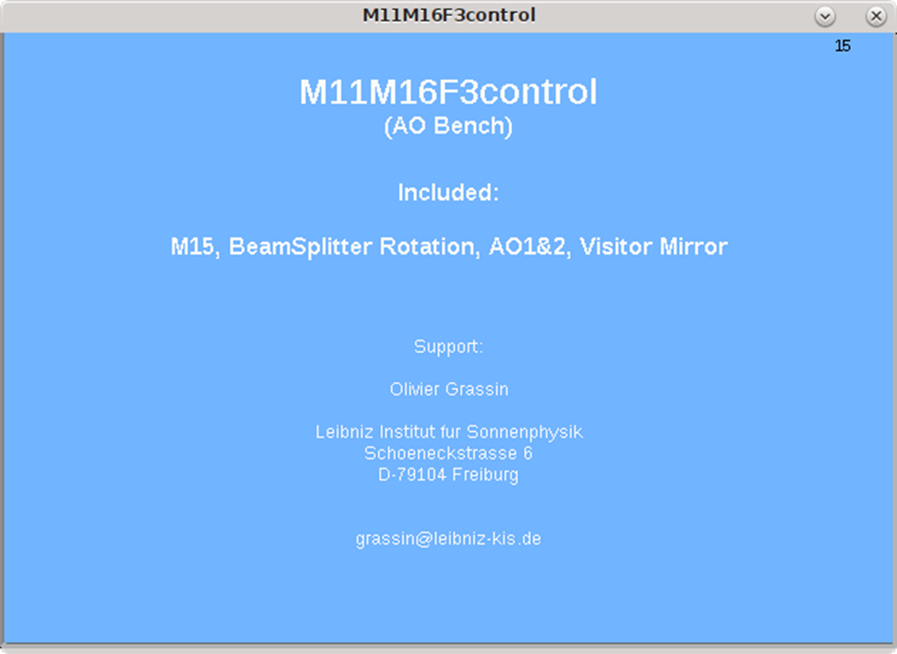

Figure 1 - Loading the interface...

Last version: Version 2023-11

# Motorization location

The beam path is coming from the telescope output window (through the Derotator if inserted) and distributed to the observation instruments.

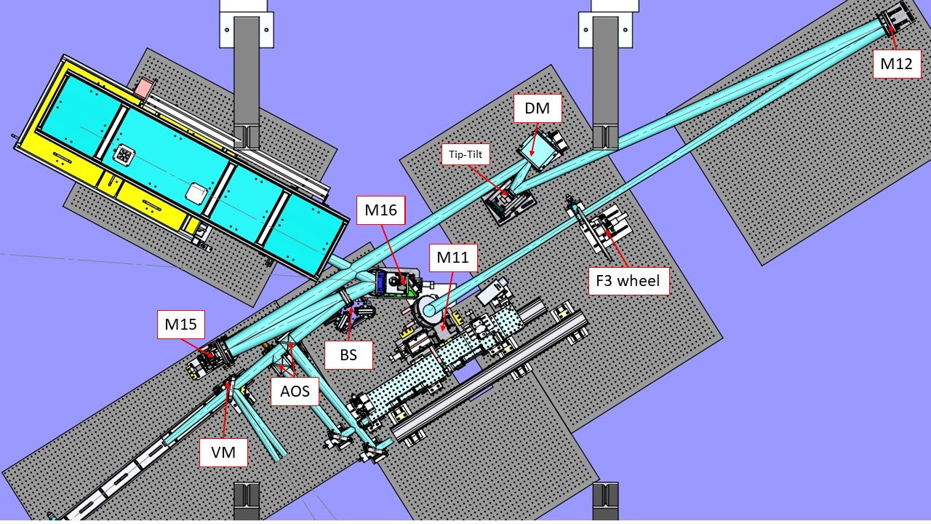

Figure 2 - Layout of the AO bench at the GREGOR 5th floor - optics lab. (Mech. draft)

* M11 Mirror 3 motors linear, elevation, azimuth
* M12 Mirror no motor - none -
* M13 (TT) Mirror Piezo actuators
* M14 (DM) Deformable Mirror Piezo actuators
* M15 Mirror 3 motors linear, elevation, azimuth
* M16 Mirror 3 motors linear, elevation, azimuth
* BS Beam Splitter 1 motor rotation
* AOS AO beam Splitters 2 motors linear
* VM Visitor Mirror 2 motors linear, rotation

# Software

The M11M16F3 interface (VI) has been developed in the LabVIEW15/64bits environment, on the CentOS7 Linux operating system.

The software manages events coming from the user front panel and remote commands through the DCP protocol from client instruments, Conductor, etc.

It also allows a "LabVIEW remote panel" connection, for the use from a remote computer, such as GREGOR Flight Stations.

## Installation

The LabVIEW15/64bits IDE is used to compile the source as an executable application.

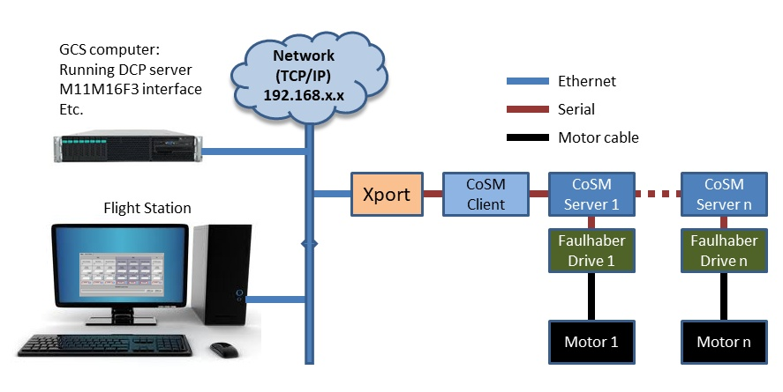

Figure 3 - Complete system diagram

It should be installed on the GCS computer, at the "/opt/G\_Control/M11M16F3/" directory,  
with two folders:

* "log" for errors and position storage (in the "motors" subfolder).
* "config" containing the configuration file for the communication, motorization and general setting.

The last source version is periodically updated after modifications and available at the KIS-GitLab site (https://gitlab.leibniz-kis.de/ot/labview/).



## Smart homing

This feature is integrated in the motor referencing function. It offers a quick referencing sequence (software only) when a motor is already powered & referenced, …after a restart of the interface, for example. (Thanks to a trick that detects if the Faulhaber driver had a power loss).

To validate the state of a motor driver, it is needed to click on its respective "Home" button.  
The "Smart Homing" is available in all motorization interfaces, as it gives the freedom to close and restart the interface without the need of referencing with movements, all the controlled motors. The resulting advantages are a gain of time (instantaneous validation), no loss of the current position, reliability and no stress!

If the referencing with movement is required, for example when a drive has been powered down (power voltage << 24V), or if the "Force Homing" option is checked,  
**the motorization will do the referencing,  
 by running the stage to find its "zero" end-switch position.**

This can last for various tens of seconds to minutes, depending of the travel range of the motor axis.

**A repositioning of the motor after a hard referencing  
(setting back its former position),   
may not bring it to the precise position as before,   
even if the position numbers are the same!**  
**Please, refer to the Optical Lab responsible person before referencing any critical motorization with movement for the observations.**

## Startup and close.

The interface software is normally in a running state, on the GCS computer. In some cases, it is needed to restart the interface; if a new version is implemented, the configuration file has been modified, OS failure, computer shut down, etc.

To avoid any problems, it is advised to start and stop the interfaces properly.

**Startup**

Verify that the M11M16F3 interface is not currently running on the system.

On the ICS interface (Gregor Instrument Control) of the GCS computer, double-click on the M11M16F3 item in the explorer menu on the left side…

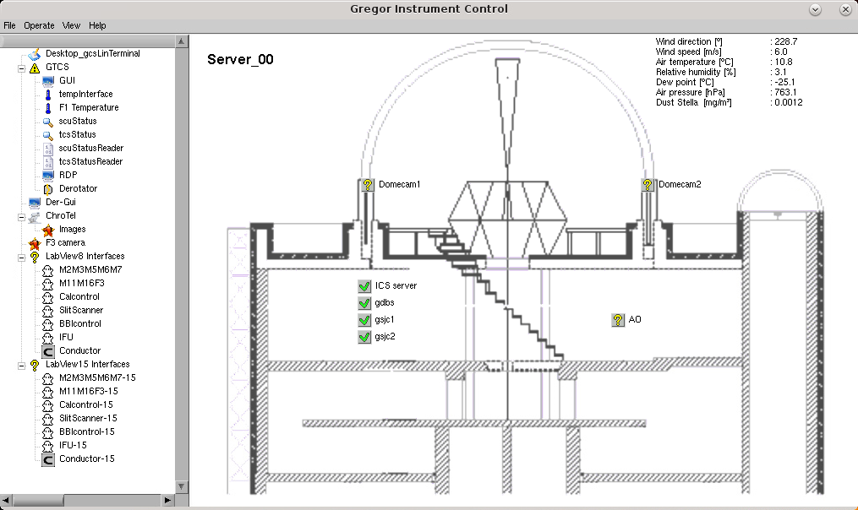

Figure 4 - ICS interface – Starting the M11M16F3 interface

Only one instance of the interface is allowed to be running; any attempt to start more will generate an error message, as the communication ports for remote panel, the DCP client name at the GCS DCP server is already used and the motorization Xport are already opened by the first one.

At startup, the GUI appears, loads the parameters and shows the main panel;

verify that the DCP and Xport indicators are connected (green).

The motorization is now ready to be referenced.

In a normal use, if all the motorization of the interface has to be referenced, after a restart for example, go to the "MAIN 1" panel, verify that the "Force homing" is **not checked**, then click the "Home All" button. => All the motorization is then "Soft" referenced instantly.

The motorization is then ready for use. For more details, refer to the "Smart Homing" section.

A remote panel of the interface is also available on the Flight Station (FS).   
Carry out the following steps to use the M11M16F3 interface remotely:

* Be sure that the M11M16F3 interface is running correctly on the GCS computer.
* Verify that the M11M16F3 interface is not running on the FS; otherwise, use it.
* On the FS, access the ICS interface (similar to the GCS ICS interface).
* Double-click on the M11M16F3 item, on the left side explorer menu, then the GUI opens.
* Use the interface.

**Close**

Depending on which interface instance is used, the closing procedure differs, creating a difference between the main instance and the remote panel instance:

* Main (on GCS computer): Always use the "Stop" button, that will start the closing sequence step by step, to quit all connections of the interface with the external world properly.

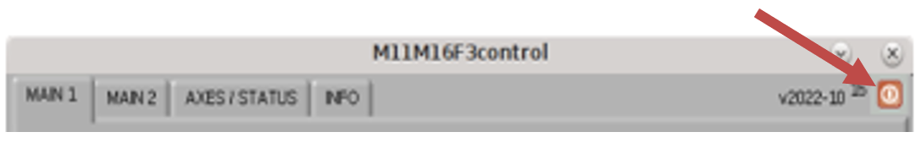

Do not use the "X" button for normal closing. This option can be tried in case of an irresponsive or frozen interface. In any case, it may take a few seconds.

* Remote panel (on Flight Stations): This case is different as it is only a virtual window that can be closed with the "X" button. On remote panels, the "Stop" button is inactive. The window closes immediately. Note that this may lead in rare cases to a white window (=crash) of the main instance on GCS, in which case a restart of that instance is required.

## Configuration file

The error log files are located in the “/opt/G\_Control/**M11M16F3**/config/” directory.  
It is recommended not to modify any parameter of the configuration file without the express clearance of the responsible person.

## Errors/Positions log

The interface registers all errors that occur and all movements of the motorization in log files available at the GCS computer.

The error log files are located in the “**/opt/G\_Control/M11M16F3/log/motors/**” directory, with a name in the format of “**M11M16F3\_yyyymmdd\_hhiiss.txt**“, keeping the date, time, Slit position, Focus positions, and last command…

The position log files are located in the “**/opt/G\_Control/M11M16F3/log/motors/**” directory, with a name in the format of “**M11M16F3-PosLog\_yyyy-mm-dd.txt**“, keeping the date, time, all motors position, and last command…

## dcpAggregator

With the introduction of a new GUI for the observations (GREGOR GUI), the heavy traffic querying motorization position information, status and remote control, has led to a communications bottleneck.

The dcpAggregator, as a DCP compliant client from one side and MQTT information broadcast server from the other, makes the link between the two systems.

The M11M16F3 interface has been upgraded to solve the issue.

The position or status of a motorization is sent to the dcpAggregator after a movement. Then, the information is automatically distributed as an event to all subscribers (mainly the GREGOR GUI). This way, the information does not have to be requested every few seconds over the DCP protocol from the M11M16F3 interface, interfering with other events. A parameter in the configuration file can toggle the transmission activation by giving a dcpAggregator name (the correct one).

# Using the interface

To startup or close, please refer to the "Startup and close" paragraph.

## MAIN 1 panel

This panel contains the functions for homing, to route the beam (M16), the wavelength selection via the beamsplitter, and the filter wheel settings.

All default positions are setup in the configuration file.

[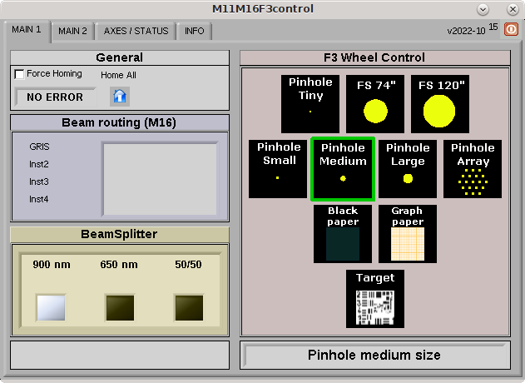](https://blog.tt.iac.es/m11m16f3main1-2022-10/)

Figure 5 - Main 1 panel

**General**

* + **Force homing:** If checked and a "Home" is sent, a referencing movement will be executed to find the zero position.   
    Each motor can also be referenced separately (See "Smart Homing" and "AXES/STATUS" chapter for more information).   
    Read the "Smart homing" section for details.
  + **Home All:** Click on this button to reference all motorization.   
    A smart homing is done, unless the "Force homing" option is checked, which leads to **real referencing movements**. Access the "AXES/STATUS" panel and check that the indicator turns to "Referenced" (green) for every referenced motor, which confirms that the motor is ready for manual positioning or remote control through DCP commands.
  + **Status:** It gives quick information about the interface events.

**Beam routing (M16)**

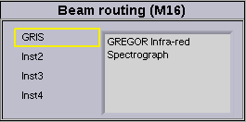

Figure 6 - Beam routing (M16)

The beam routing selector allows the user to configure the position of the M16 mirror, for a dedicated instrument. Currently, GRIS is the only option and M16 should not be moved due to potential backlash. Click on the instrument list to select it, then wait for the motorization movements to be done. (it would also be possible to move M15 for the beam routing, which can be enabled or disabled in the configuration file.)

**BeamSplitter**

Select the required position of the Beam Splitter here, by clicking on one of the 3 buttons.  
The white-colored box will show the device position after the rotation. (White = ON)

**F3 Wheel Control**

The wheel at F3 holds different optical devices for calibration/observation usage.   
By clicking on the icons on the right, the filter wheel will move to the desired position. It can take a few seconds to be executed. The squared selector turns **blue** to show the possible choice. When clicked, the wheel begins to turn and the selector turns **orange** (movement), then changes to **green** when it reaches its position. These positions are setup in the configuration file. The name of the selected device will appear in the indicator below the selector, once the final position is reached.

***Never move the wheel by hand, it will damage the Harmonic drive high precision gears!***

## MAIN 2 panel

The second panel enables choices for the AO beamsplitter cube and the instrument light distribution in the visible beam.

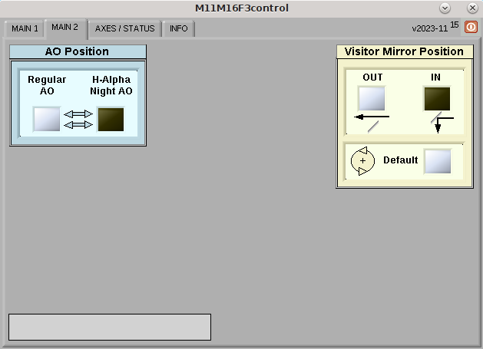

Figure 7 - Main 2 panel

**AO Position**

This selector allows to select the AO mode to be used. One action will move 2 motors together, with their respective beam splitter, on or off the beam path. (White = ON)

**Visitor Mirror Position**

As a double selector, the user can configure to which instrument the beam is directed.

If the mirror is OUT, the beam goes straight to the BBI instrument, etc.

If it is IN, the button for rotation, can set the default position. (White = ON)

**Status indicator**

It shows the status of the interface/motorization; Idle/Busy/Error/Not ready…

## AXES/STATUS panel

[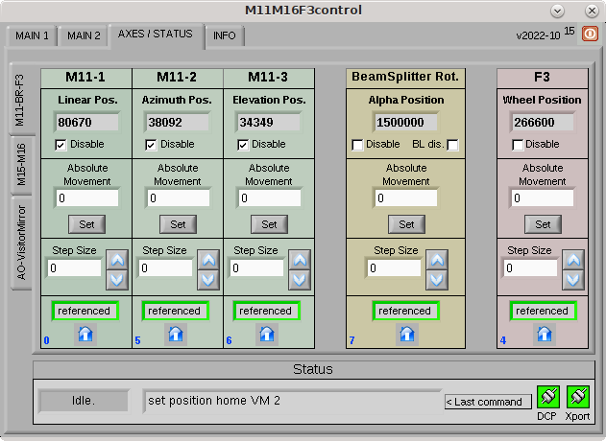](https://blog.tt.iac.es/m11m16f3axes1-2022-10/)

[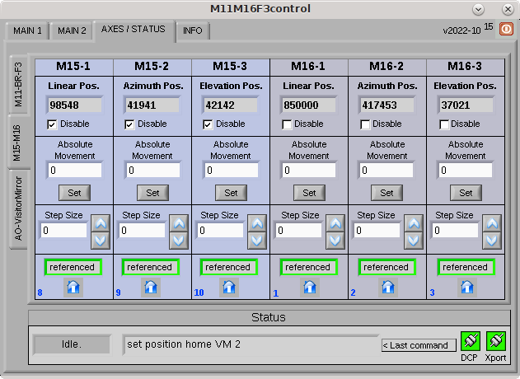](https://blog.tt.iac.es/m11m16f3axes2-2022-10/)

[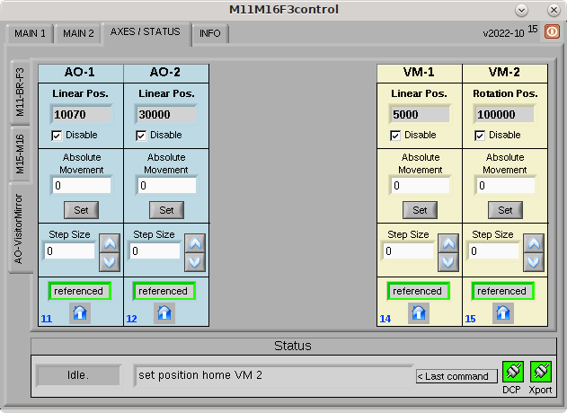](https://blog.tt.iac.es/m11m16f3axes3-2022-10/)

Figure 8 - Axes/Status panels

It is sometimes needed to manually adjust the position of a motor. These panels help the user to reference, set the desired positions, or send step increments/decrements of a specific motor:

**Position indicator**

It shows the current motor position as defined by the encoder (steps).

**Disable**

Select this option if the motor power needs to be disconnected after a movement.

It will be automatically re-enabled for a movement, then disabled again.

If the motorization is moved manually, or some force is applied due to weight or flexion, the position may change, but it will not be reflected in the indicator (no automatic refresh).

**BL dis.** (only for BeamSplitter Rotation axis)

As this motorization axis has a mechanical backlash with respect to the taken rotation direction (not seen on the encoder), the position reached is not exactly the same clock-wise or counter clock-wise.

To compensate, the software always sends a final movement to always reach the position from the same side. No backlash compensation will be done, if this option is checked.

(A tooltip will appear, to explain the function, if the mouse cursor is set over the box)

**Absolute movement**

Enter a value into the respective control and click the "Set" button to move the motor to the desired position. The movement is executed.

**Step**

To move the motor by steps, enter the step size into the respective control. The movement is executed using the up & down arrows. If the destination position is out of range, the movement is not done. From DCP, an error message is returned.

**Motorization status**

This indicator has 3 states:

* +  When the motorization state is unknown at start up or when an error occurred. Motorization needs to perform a "Home".
  +  The motorization is moving to the referenced "0″ position.
  +  The motorization has referenced and is ready for position movements.

**Home**

Button for referencing and to validate the motor.   
The "Referenced" indicator must be green, to allow movements.

**Status**

* + **Status:** Interface information (Idle/Busy/Error/Not ready)
  + **Last command:**This indicator shows the last action done, DCP or manual mode. (internal parameters displayed)
  + **Communications:** In normal use, the interface is always connected to the DCP server and to the Xport device for the motorization dialog.



Indicators must turn green after a good connection.

If one or both remain red after startup, there is a communication problem.

This should be solved before proceeding.



## INFO panel

[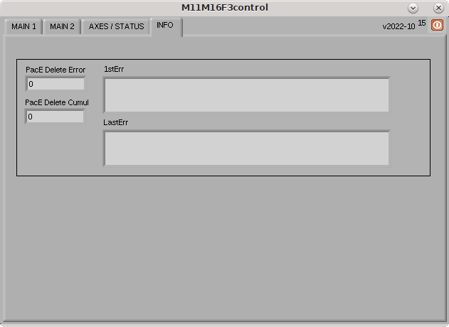](https://blog.tt.iac.es/m11m16f3info-2022-10/)

Figure 9 - INFO panel

This panel was added to show possible issues generating big error files in the last years, related to a communication loss between the interface and the DCP server. The reason could be a network issue or if the DCP server stopped/froze/was not started.

The M11M16F3 software is now able to detect the cases and ignore the subsequent errors in the log file, just keeping the first one, showing the current error event and the total number of occurrences.

The only action to take if the error is detected, is to fix the problem and reestablish the connection with the DCP server. Meanwhile, it is not possible to move the motorization remotely.

## Motorization limits

The motors cannot be moved by manual or remote control over their limits; in a first step, it is the software limits, defined in the configuration file that prevents to move beyond.

There are also hardware limits, fixed into the motor driver parameters, placed just after the software limit range, to definitively block the motion.

Any unauthorized modification of these limit parameters could lead to serious damages of the motorization and even more, to optical and mechanical devices of the bench.

**Please, refer expressly to a responsible person before any change.**

# Technical data

## Filter wheel positions

|  |  |  |
| --- | --- | --- |
| Device index | Device | encoder position |
| 0 | Pinhole medium | 266600 |
| 1 | Pinhole large | 226650 |
| 2 | Pinhole tiny | 186600 |
| 3 | Graph Paper | 146700 |
| 4 | Field stop 74" | 106650 |
| 5 | Pinhole Small | 66650 |
| 6 | Target | 27650 |
| 7 | Black Paper | 386850 |
| 8 | Pinhole array | 346650 |
| 9 | Field stop 100" | 306550 |

## CoSM modules – daisy chain configuration

IP: 192.168.90.77

**Xport**

CoSM Client

**­­­F3 Wheel**

#75

**M11-l**

#52

**M11-e**

#77

**M11-a**

#76

**M16-l**

#72

**M16-a**

#73

**M16-e**

#48

**BR-a**

#58

**A01-l**

#57

**AO2-l**

#56

**M15-l**

#55

**M15-a**

#45

**M15-e**

#46

**VM1-l**

#53

**VM2-r**

#54

Figure 10 - CoSM modules - daisy chain configuration

Extensions:

* a Azimuth
* e Elevation
* l Linear
* r Rotation

# DCP commands

To use the DCP functions, this interface name is: **M11M16F3control**

The current command list, for the remote use of the interface and its motorization:

* "**set nop**" for communication test
* "**set position abs**" for axis absolute position
* "**set position rel**" for relative movement
* "**get position abs**" for reading axis position
* "**set position def**" for sending axes to the default position
* "**get position def**" for reading axes default positions

For detailed information and parameters, please refer to the specific lastly updated documentation, available in the blog:

M11M16F3 - DCP Commands Rev4.pdf – (2023-11-15)

# What’s new?

**2023-11**Visitor Mirror:

* Modified VM2 (rotation) positioning, reduce the 2 positions button to one default position.
  + Modified the configuration file for the "VM2-pos 1" to "VM2defaultRot" position parameter.
* Cosmetics for VM1 (linear) buttons.
* DCP commands update for Visitor Mirror (Rev4).

**2022-10**Major cumulative update from last versions:

* Added new motors (6).
  + M15z linear axis, BeamSplitter rotation axis, AO1 & AO2 linear axes,  
    Visitor/BBI linear axis, Visitor GFPI rotation axis.
* Font panel, added new panes:
  + Main1
    - Beam routing (M16) update.
    - BeamSplitter selector.
  + Main2
    - AO position: AO1 and AO2 motorization (2 beam splitters on linear axes).
      * Regular AO
      * H-alpha / Night AO
    - Visitor Mirror position
      * Visitor / BB1 linear axis
      * Visitor / GFPI rotation axis
  + AXES /STATUS  
    All axes, option to "Disable" the driver after a movement.  
    BeamSplitter "Backlash disable" option.
    - M11, BeamSplitter, F3 wheel
    - M15, M16
    - AO1 & AO2, Visitor
  + INFO
    - "PacE delete" error display and filtering
* New DCP commands
* Configuration file modifications, (not compatible with previous versions)

**2018-10**Major update:

* New M15 motorization (x and y)
* All motors referencing (1 button)
* Instrumentation beam selector (M16/M15) – 4 positions
* M11 AO-No AO option removed
* Configuration file reorganization

**2017-07**

* "Open 2" wheel position is now "Pinhole array" and moved to pinhole line.
* Correction of bug at F3 blue selector remaining on, after fast mouse move outside of it. Also, the blue selector now disappears when the wheel is moving.

**2017-03**

* F3 selector redesign.
* Some little bugs correction in configuration file and VIs.

**2016-04**

* Field Stop FS 147″ value is set to real size, now FS 100″.  
  (only configuration file modification)

**2015**

* New check box associated to the M16 Phi motor as option to disable it after movement.
* Bug correction of DCP communication, producing aleatory delay to answer messages to client (all interfaces).

**REVIEW 2013-2014**

Here down, the list of the new improvements applied to the M11M16F3 Interface in the last months available for now (2014-05):

* Smart Homing
* New DCP commands
* Other improvements & cosmetics

**New DCP commands**

* “set nop” command has been added to perform a communication test through the DCP protocol. Any sender could know if the interface is responding.

 Document: [M11M16F3 – DCP commands](https://blog.tt.iac.es/wp-content/uploads/2009/08/M11M16F3-DCP-Commands.pdf)  – M11M16F3control (2013-10-24)

DCP identifier & desktop interface name: M11M16F3control

Other improvements & cosmetics

* Added “Last Command executed” for information display, works both with DCP or manual commands.
* “Referenced” indicators behavior; more accurate display with “Warning” when moving.