LEIBNIZ INSTITUT FÜR ASTROPHYSIK POTSDAM | LEIBNIZ-INSTITUT FÜR SONNENPHYSIK (KIS) | MAX PLANCK INSTITUT FÜR SONNENSYSTEM-FORSCHUNG

GREGOR:
<SJ Alignment Manual>

Document No.: | GRE-KIS-MAN-0015
Version: | <1>
Date: | <30.6.2020>

Signatures & Approval
 |  | Name | Signature |  | Date
Prepared by |  | Lucia Kleint - KIS  OT Head |  | <4.6.2020>
Reviewed by |  | Miguel Esteves – KIS  Mechanical Engineer |  | 24.6.2020
Approved by
Released by

Change Log
Vers. | Date | Author | Description of Changes | Sect./Para.
 | 2.10.18 | L. Kleint | New Document
 | 4.6.20 | L. Kleint | Update to contain more details how to align SJ from scratch | all
 | 5.6. | L.Kleint | Added potential pupil displacement and autocollimation for f=300 lenses.
1 | 22.6. | L. Kleint | Added Miguel’s images and clarified questions.

Table of Contents
1 Scope 3
2 SJ alignment 3

List of Figures
Figure 1: Checking beam height and SJ orientation. Note that the picture shows a situation where the beam (green laser) is not yet at the correct height. 3
Figure 2: Left: Target being moved on rail. The beam stays on the vertical line (also when moving the target in the opposite direction) indicating a good rotational alignment of the SJ cabinet. Right: The future position of M1SJ. 4
Figure 3: Left: center alignment of the f=750 mm lens using paper behind the lens. Right: Center alignment of the f=750 using mm paper centered in front of the lens. Both methods are fine. 4
Figure 4: Back-reflection of target on slit during autocollimation. 5
Figure 5: Setup for alignment telescope. M2SJ and the flat mirror just above it do not need to be aligned precisely. 6
Figure 6: Setup with f=1000 lens for alignment of f=750 lens. 7
Figure 7: Left: in focus. Right: slightly out of focus (note the blurrier slit). In this case the focus test was done by moving the lens with its motor, to make sure that 24000 corresponds to the optimum focus position. This test is good once the ideal lens position is found. One can try setting the focus to 20000 and to 28000, which should lead to an equal defocus compared to 24000. 7
Figure 8: This is what the GREGOR pupil looks like 8
Figure 9: target left of 80/20 beamsplitter. In this image, the beamsplitter should be moved vertically (up, towards ceiling) slightly because the light beam is not perfectly centered in the cross. 9
Figure 10: Lens alignment. The transparent mm paper allows us to see if the margin is identical on all sides. 10
Figure 11: Final setup of SJ. The MPS/GRIS+ part (including the 90/10 beamsplitter) can be omitted. 11

Scope
This document explains the full SJ alignment to be done after the optics redesign.

SJ alignment
The assumption is that all optical components are removed from the SJ system.
Coordinate system:
z: parallel to beam
x: perpendicular to beam
y: height (205 mm)
Notes:
- before removal, we placed stops to mark the original position of each element. If I remember correctly, the stops were placed to the left of each optical element, apart from M1SJ, where there was no space. They can serve as a rough guideline where to expect the optical elements.
- use the glass plate, otherwise the light will not be visible in the SJ system. Note that the AO does not lock properly on the target with the glass plate. In the future, use the 650 nm plate.

Alignment of SJ cabinet
- Check that the beam height is correct in the SJ system by mounting a target with h=205 on the lowest rail. This probably works best with a pinhole in F3. If it is not at 205, move the whole SJ system mechanically perpendicularly to the beam direction.
- Move the target a little back and forth on the rail in z-direction (I guess ~10 cm) to see if the reflection remains at h=205. If not, then the SJ cabinet is rotated and at least one of its supports has to be moved mechanically. Even though the distance of motion is small, the rotation of the cabinet is not so critical to spend more effort on this.
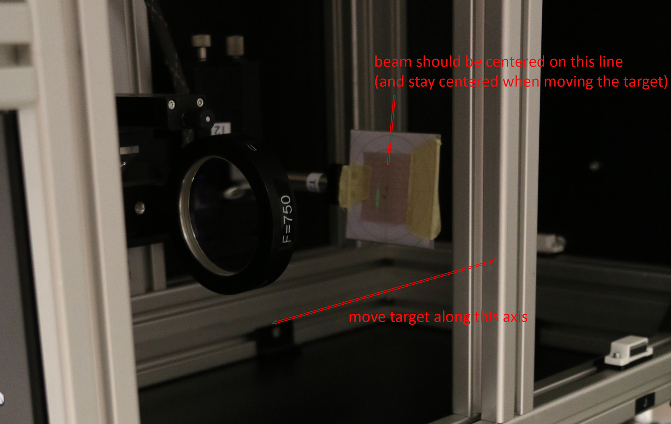
Figure 1: Checking beam height and SJ orientation. Note that the picture shows a situation where the beam (green laser) is not yet at the correct height.
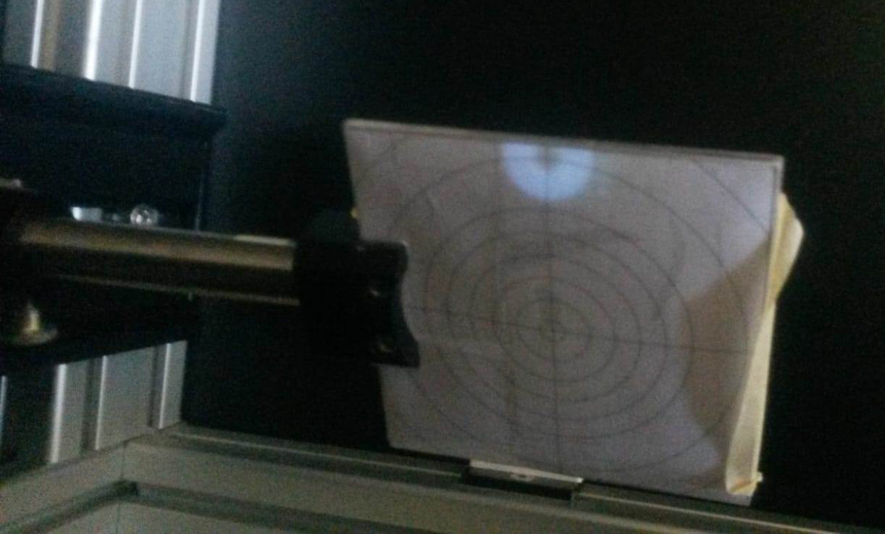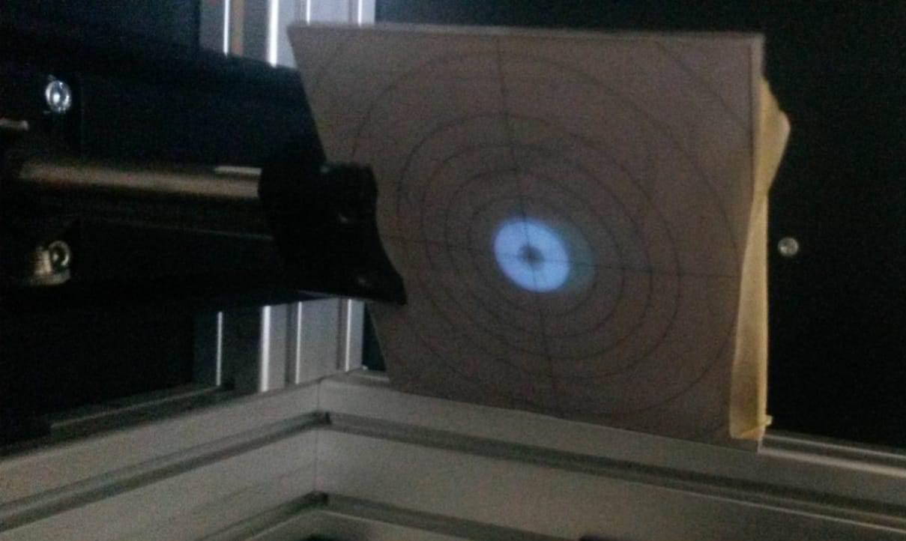
Figure 2: Left: Target being moved on rail. The beam stays on the vertical line (also when moving the target in the opposite direction) indicating a good rotational alignment of the SJ cabinet. Right: The future position of M1SJ.

Alignment of M1SJ and the lens
- Place M1SJ on the right side of the rail. Ideally, it should be illuminated centrally, which determines its position along the rail. The central illumination is not critical though (few mm shift does not matter).
- If there is vignetting, one can remove (unscrew) the black movable cover on the bottom of the SJ cabinet. You can adjust the height of the mirror above the rail to center the beam better.
- Put the target left of M1SJ on the rail. The f=750 mm lens should not be on the rail at this time.
- Tilt M1SJ such that the beam is centrally illuminating the target. Shift the target along the whole rail, it must remain illuminated centrally. This makes sure that M1SJ deflects the beam perfectly along the rail, the beam shall neither have an inclination, nor change height.
- The lens should be moved with the slitscanner GUI to around 24000 (its middle position).
- Place the lens left of M1SJ, the distance does not matter yet. Move it in x,y to be illuminated centrally and it should be perpendicular to the beam. Based on experience, this is hard to see, the best seems to be holding a transparent paper on one side, plus looking at it without much parallax.
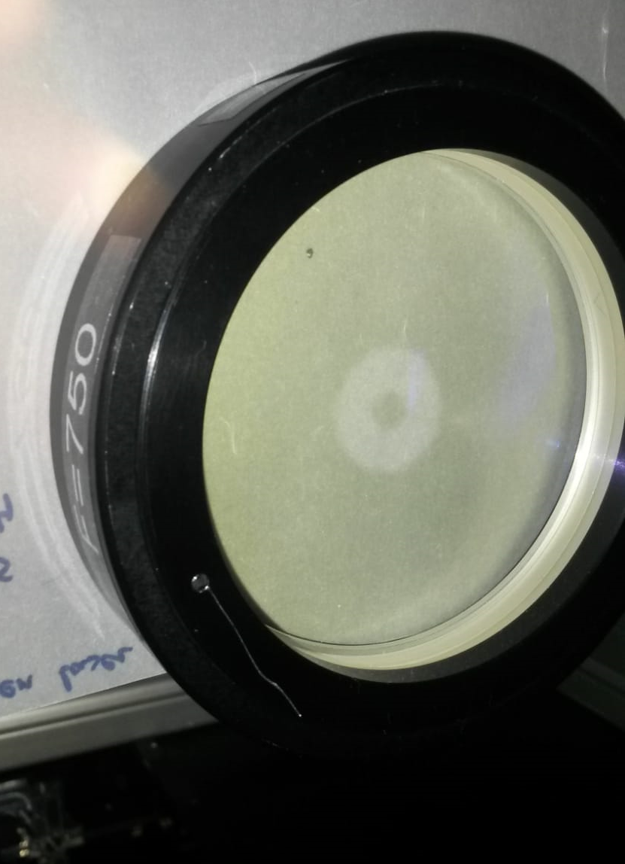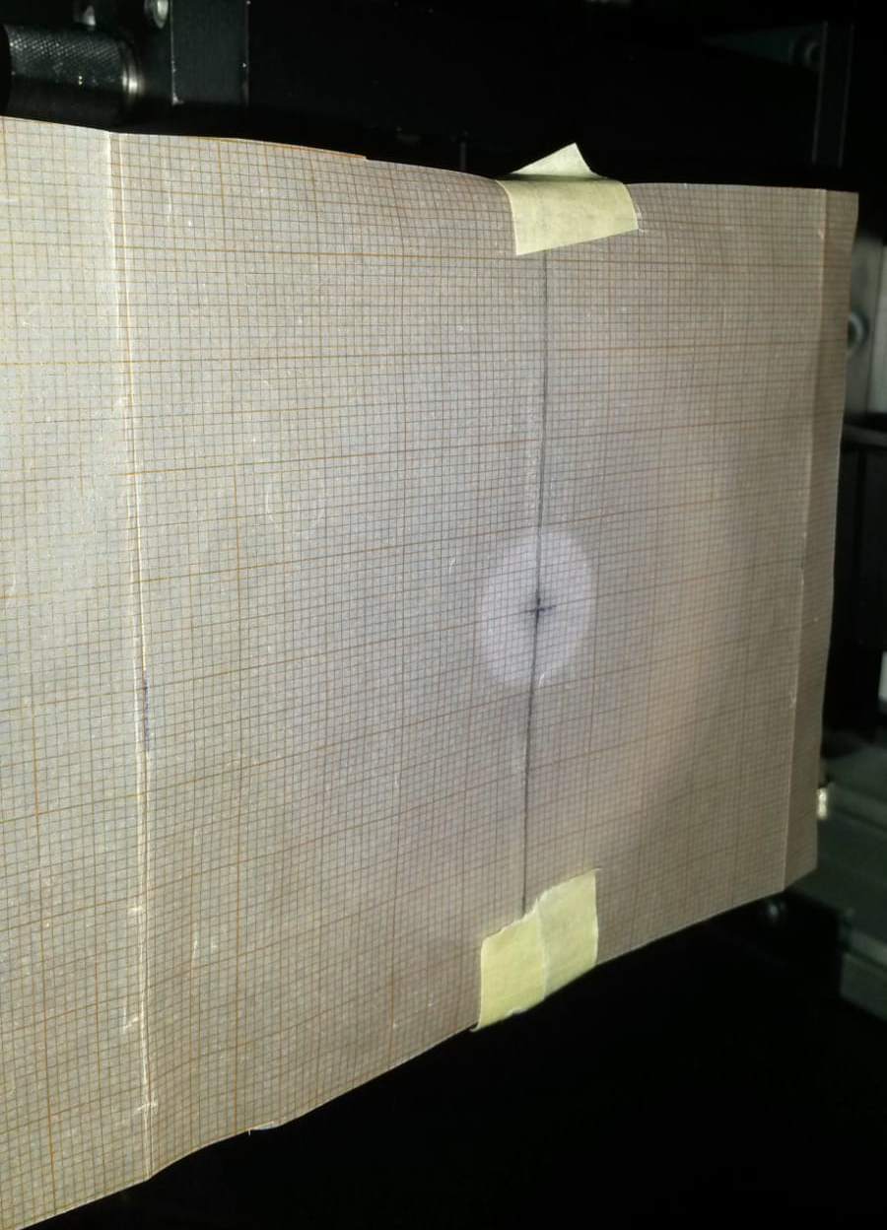
Figure 3: Left: center alignment of the f=750 mm lens using paper behind the lens. Right: Center alignment of the f=750 using mm paper centered in front of the lens. Both methods are fine.
- To determine the correct position of the lens along the rail, one can use 3 methods:

Autocollimation (least exact method, but fast)
  - Put any flat mirror (for example the visitor mirror) left of the lens on the rail, the distance from the lens does not really matter. Lock the AO on the target.
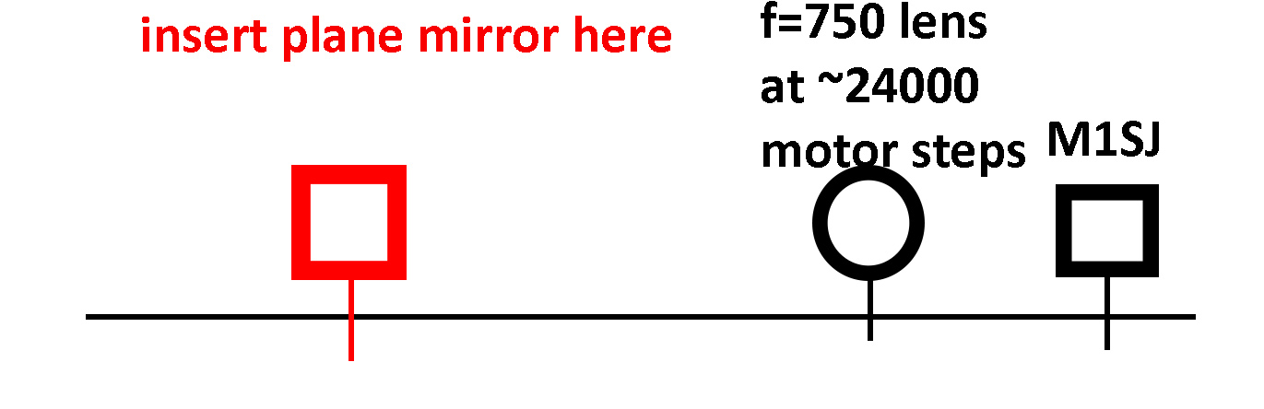
  - Tilt the plane mirror by watching the back-reflection of the target on the GRIS slit. The goal is to reflect the target image through the lens and M1SJ to the slit, with a small offset with respect to the primary target image, which directly appears on the GRIS slit.
  - Now move the lens along the rail, while watching the reflected target image. When it becomes perfectly sharp on the GRIS slit, then the lens is in its correct position.
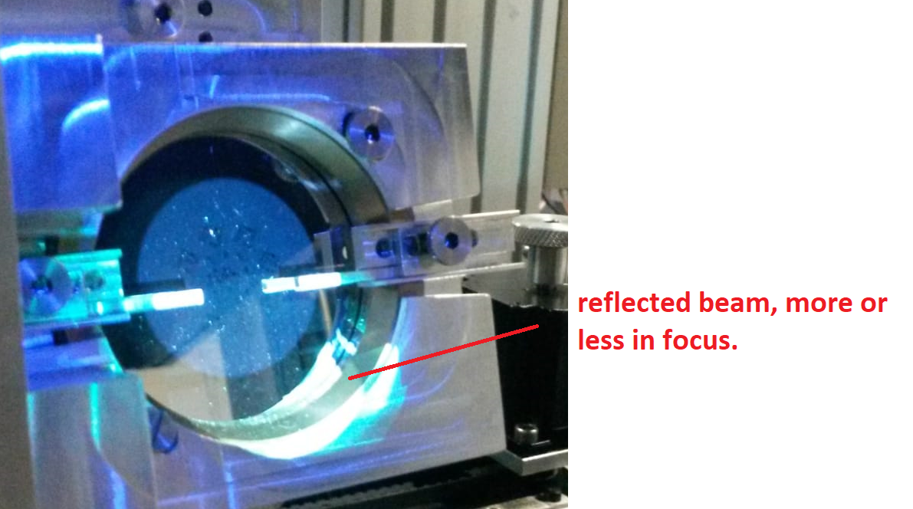
Figure 4: Back-reflection of target on slit during autocollimation.
  - If there is a collision between lens and M1SJ during this procedure, move M1SJ a little to the right (even if it is then illuminated a little too high, which does not matter). If M1SJ was aligned properly, this will not change the beam height along the rail. But this will change the x-position of the beam, which means that the lens has to be moved in x, such that it is again illuminated centrally.
  - Repeat this procedure until lens and M1SJ do not collide and the reflected target is sharp. There is convergence because for each distance that M1SJ is moved, the lens only needs to be moved distance/2.
  - Test that when the lens is moved via motor to its end position, it cannot collide with M1SJ.

Method with an alignment telescope.
- Mount any alignment telescope on the lowest (GRIS+) rail, towards the left of the rail. Before doing so, make sure the alignment telescope is focused to infinity (for example by pointing it to Teide).
- Mount some flat mirrors (M2SJ and another one) to deflect the light into the telescope. These mirrors do not need to be well-aligned, just make sure light gets into the telescope.

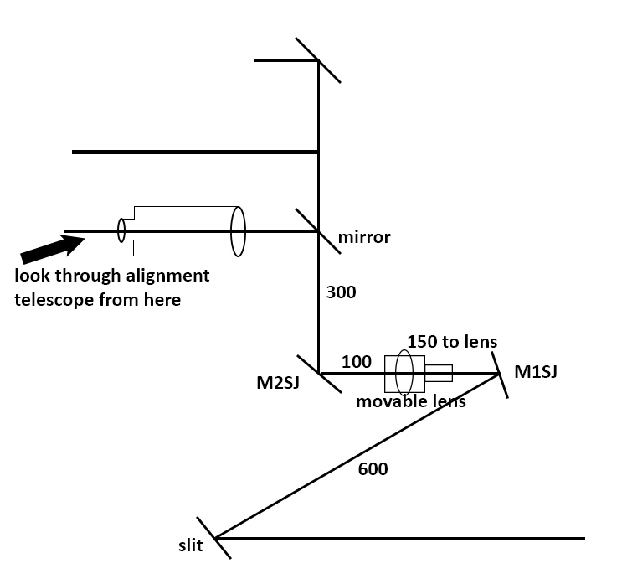
Figure 5: Setup for alignment telescope. M2SJ and the flat mirror just above it do not need to be aligned precisely.
- Now look through the telescope. You will probably see a blurry target. Move the lens until the target becomes sharp. This should give the same z-position of the lens as the autocollimation method.
- If the lens and M1SJ collide, see step (d) above and repeat the procedure after shifting M1SJ.

Method with f=1000 lens and SJ camera
- If you do not have an alignment telescope, the same procedure can also be done with a lens with f=1000 mm (long focal lengths are better, much longer than f=1000 would not fit on the rail). Place the SJ camera as far left as possible and then (with a ruler), place the lens 1000 mm (+-5 mm) to the right of it. Note: This also works with e.g. a f=800 lens if you cannot find one with f=1000.
- Tilt the 2 folding mirrors, such that the beam hits the camera. Do not worry about their alignment much, the goal is just to have light in the camera.
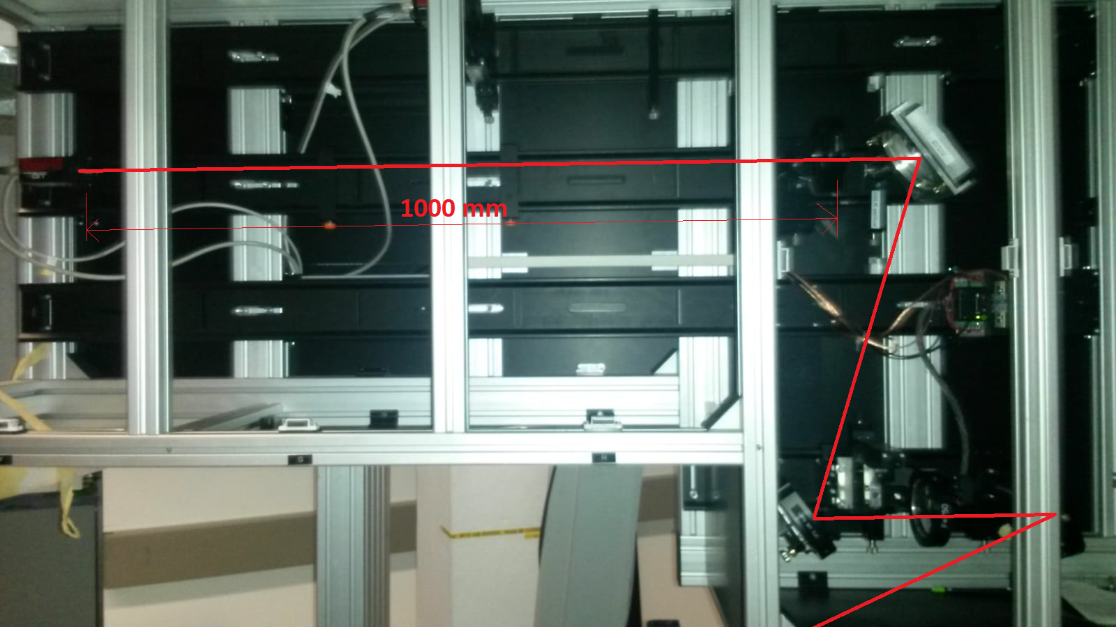
Figure 6: Setup with f=1000 lens for alignment of f=750 lens.
- Now you should be able to see a potentially defocused target on one of the SJ cameras in the GUI. It is defocused because M1SJ and the lens may not be in their proper positions yet and the distance of the slit mask to the lens is not correct yet.
- Look at the SJ image on any FSG and move the motorized lens mechanically until the target becomes sharp.
- If there is a collision between lens and M1SJ, see step (d) above and repeat the procedure after shifting M1SJ.
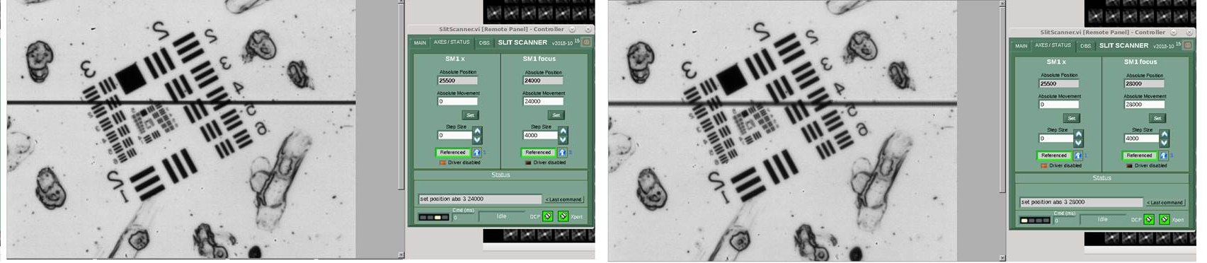
Figure 7: Left: in focus. Right: slightly out of focus (note the blurrier slit). In this case the focus test was done by moving the lens with its motor, to make sure that 24000 corresponds to the optimum focus position. This test is good once the ideal lens position is found. One can try setting the focus to 20000 and to 28000, which should lead to an equal defocus compared to 24000.
After performing these steps, M1SJ is correctly aligned, sends the light centrally through the lens, and the lens is in the correct distance to the slit.

Alignment of M2SJ
The goal of this alignment step is to place M2SJ, such that the beam goes vertically up.
- Remove the 45 deg alignment mirror if you used an alignment telescope or the SJ cam.
- Place M2SJ. Its z-position does not matter much. We put stops when we removed the elements, just place it in its original location.
- Check that the mirror is illuminated more or less centrally. Few mm do not matter.
- Tilt the mirror to make the beam go up vertically. Potentially use a plummet or any mechanical tool to verify the vertical direction.

Alignment of the top rail
The top rail contains the continuum channel. In this step, we align the beam to go along this rail and be focused on the camera.
- Place the folding mirror, which deflects the light into the top rail. Lock the AO on a pinhole.
- Put a target close to the mirror on the top rail. Is the beam height on the target=205? If not, then tilt M2SJ because this would mean that the top folding mirror is not hit at the correct height.
- Move the target far to the left on the rail. Now tilt the top folding mirror, such that the height and x are correct on the target.
- Move the target along the rail, the beam should remain centered on the target. If it is not, repeat the previous steps until you converge to a beam, which does not move in x and height along the rail.

- Use FS=120 (or 100) in F3. AO can be unlocked, just make sure that pupil tracking is on. Now use a piece of paper to find the location of the pupil in the vertical beam. This means find the location where the spiders and the central obscuration look the sharpest. This will be about 750 mm from the motorized lens. Mark this position (+-5 mm). In June 2020 we found a pupil position of 760 mm (instead of 750 mm) after the lens, which means that the exit pupil is not at infinity (contrary to the GREGOR design). This should not affect the image quality, but should be investigated in the future. A potential cause is a slight offset of the TT or DM distances.

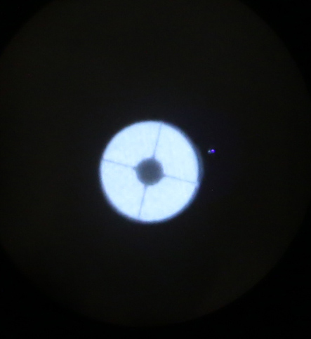
Figure 8: This is what the GREGOR pupil looks like
- Temporarily insert the 80/20 beamsplitter near the middle rail (rough centering is ok) and check that the pupil does not shift towards ceiling/floor. If it does shift, then use the new pupil position as reference. If the insertion of the beamsplitter shifts the beam laterally on the top rail, this means the beamsplitter is not perpendicular to the beam and should be tilted until there is no change in beam position on the top rail with/without beamsplitter.
- From this pupil position, measure 300 mm with a ruler (vertical component and component along the top rail) and place the f=300 lens at that place. The precision is not so critical, try to be as precise as possible.
- Move the f=300 lens to be perpendicular to the beam and illuminated centrally. This is important, otherwise the image quality degrades.
- The perfect z-position of the f=300 lens could be found more exactly by autocollimation, but probably is not necessary here. If you want to do autocollimation: place a flat mirror left of the lens, align it such that the back-reflected light goes in a similar path. Now hold a piece of paper at the pupil position. If the pupil is sharp in the direct beam and in the reflected beam, the f=300 lens is in the correct position. If the pupil is unsharp in the reflected beam at the desired pupil position, move the f=300 lens until it becomes sharp.
- Put the ND filter and the 777 nm filter on the top rail. Their z-location does not matter, the ND filter should be on the right of the 777 nm filter. Usually, the images look better when filters are located close to the camera. The more reflecting side of the 777 filter should face towards the Sun.
- Lock the AO on the target. Focus the camera by looking at the slit in the SJ GUI. When the slit (black line) is sharpest, this is the location of best camera focus.
- Move the camera in x and y and rotation if necessary, such that the slit is horizontal (can be checked by using the crosshair in the GUI) and the F3 pinhole is centered in the SJ image (again, by looking at the crosshair).

This means the top rail is aligned. A problem however is that the 900 nm plate will not let any light through at 777 nm and therefore we will need interchangeable SJ filters. But we will deal with this at a later alignment step.

Alignment of the middle rail (the H-alpha beam)
- Place the 80/20 beamsplitter cube. Its orientation can be checked by holding a piece of paper to the left of it and to the right of it and making sure that the majority of the light is reflected to the left (=to the H-alpha beam).
- Lock the AO on a pinhole. Check with a piece of paper that the cube is illuminated centrally (bottom and top sides). If not, shift the cube for the beam to be centered on the cube.
- Place the target on the middle rail, just left of the cube. If the beam is not centered on the target in x, then move the whole 80/20 beamsplitter assembly vertically (towards floor/ceiling).
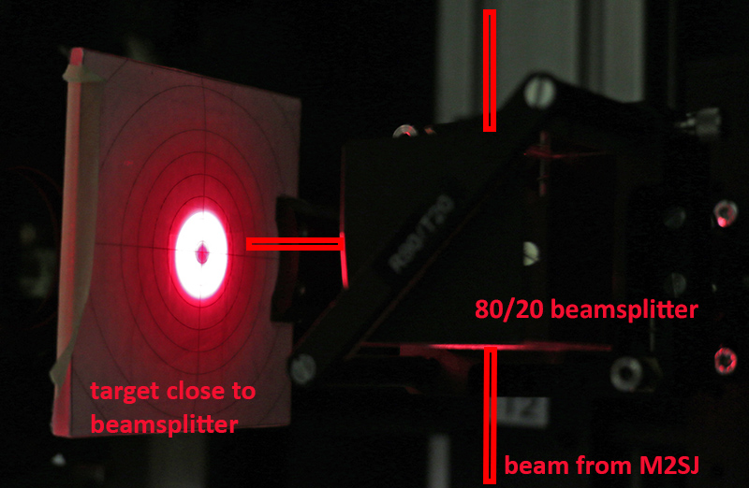
Figure 9: target left of 80/20 beamsplitter. In this image, the beamsplitter should be moved vertically (up, towards ceiling) slightly because the light beam is not perfectly centered in the cross.
- Move the target further to the left on the rail. If the beam is not centered on the target, then tilt the beamsplitter cube.
- Repeat the two above steps iteratively until you converge to a beam, which does not move on the target, when the target is shifted along the rail.
- Use FS=120 (or 100) in F3, do not necessarily lock the AO, but make sure pupil tracking is on. With a piece of paper, try to find the pupil, i.e. where the spiders look sharpest. Mark this position. It should be about 15 cm (+-5 cm) to the left of the beamsplitter.
- From this pupil position measure 300 mm to the left along the rail and place a f=300 lens there. This could be done more exactly by autocollimation, but probably is not necessary here. If you want to do autocollimation: place a flat mirror left of the lens, align it such that the back-reflected light goes in a similar path. Now hold a piece of paper at the pupil position. If the pupil is sharp in the direct beam and in the reflected beam, the f=300 lens is in the correct position. If the pupil is unsharp in the reflected beam at the desired pupil position, move the f=300 lens until it becomes sharp.
- Move the lens to be illuminated centrally and to be perpendicular to the beam.
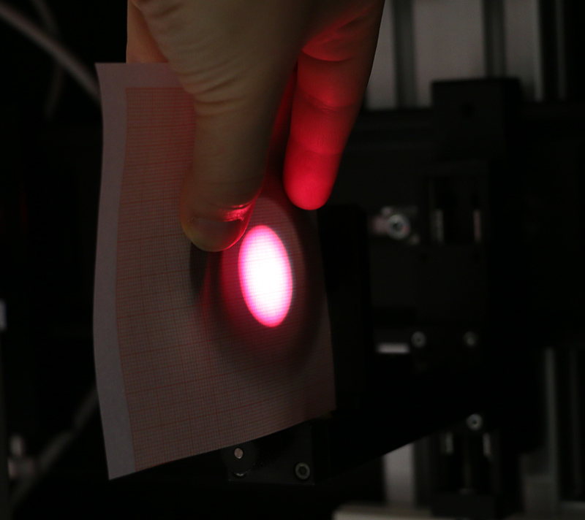
Figure 10: Lens alignment. The transparent mm paper allows us to see if the margin is identical on all sides.
The Lyot reduces the beam intensity by many factors, which means it cannot easily be used for a first alignment. We will therefore borrow the filters from the top rail and put them on the middle rail for a first rough alignment.

- Move the ND filter and the 777 nm filter onto the middle rail, left of the f=300 lens. Block the top rail beam (to avoid too much light hitting the camera) with any mask.
- Lock the AO on the target. Focus the middle rail camera by looking at the slit in the SJ GUI. When the slit (black line) is sharpest, this is the location of best camera focus.
- Move the camera in x and y and rotation if necessary, such that the slit is horizontal (can be checked by using the crosshair in the GUI) and the F3 pinhole is centered in the SJ image (again, by looking at the crosshair).
- Move the ND filter and the 777 nm filter back to the top rail and block the light in the middle rail to avoid too much light on the camera.

Now we have aligned all beams, but the camera focus position (z-direction) will change depending on which filter (or the Lyot) is used. For now, we skip the Lyot part because the 650 nm beamsplitter is still in Freiburg and the Lyot is being used in BBI.

The setup should now be as shown in Fig. 4 apart from the 90/10 beamsplitter and the f=400 lens, which currently are not required and not installed (they are only for GRIS+). Also, the Lyot is currently not in place.

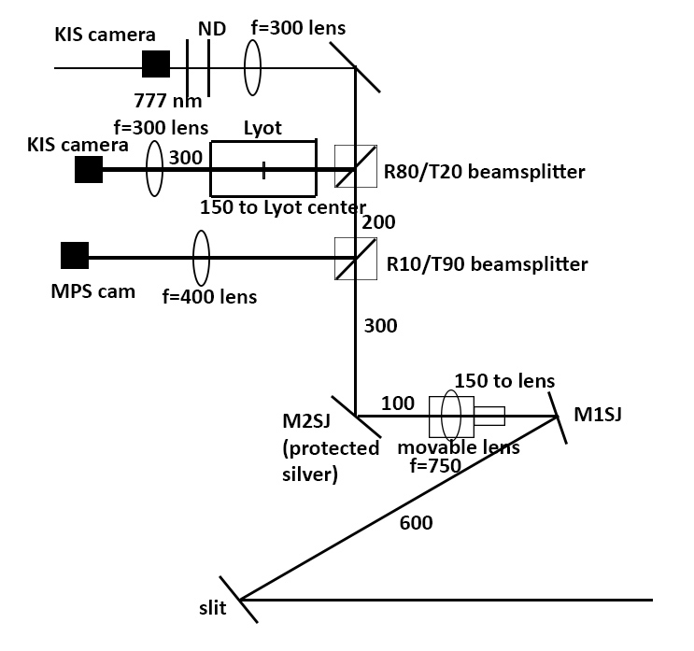
Figure 11: Final setup of SJ. The MPS/GRIS+ part (including the 90/10 beamsplitter) can be omitted.

New filter for continuum beam when using the 900 nm beamsplitter
When using the 900 nm beamsplitter, all wavelengths below 900 nm go towards the AO/BBI. This means the SJ H-alpha channel is useless and the 777 nm filter also would not get any light.

We therefore need to replace the 777 nm filter with a filter between 900-1000 nm. The SJ camera is still sensitive at those wavelengths, but the integration time may increase. Note: The 971 nm filter has high transmission and does not increase the exposure time (5 ms).

- Check the filter list for any filters between 900 and 1000 nm:
http://www.leibniz-kis.de/fileadmin/user_upload/vtt_filters_17.pdf
- Boxes D and E may be your best bet. Bring several of those filters to GREGOR, e.g. 905, 971, 988 (note that they may be labeled in Angstrom, e.g. 9710 A).
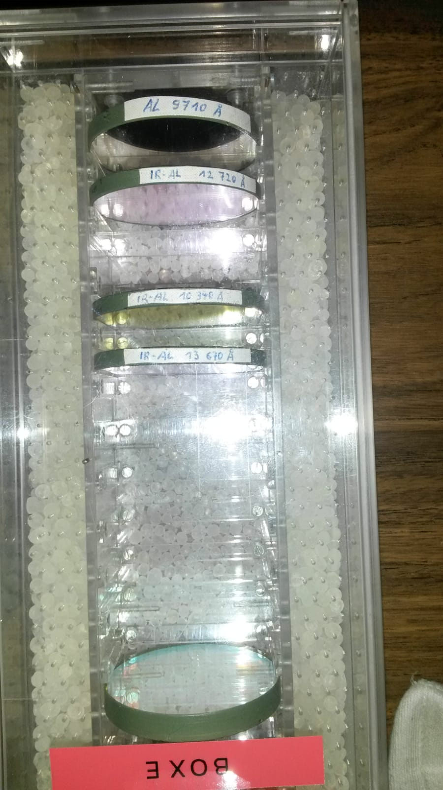
- Mount the filters in holders (one at a time is fine).
- Remove the 777 nm filter and try the >900 nm filters. The filter shall be mounted with the more reflecting side towards the Sun.
- Set the exposure time in the SJ GUI to 5 ms. If you see nothing, remove the ND filter in the top rail. If you still see nothing, increase the exposure time up to 25 ms.
- Try this until you find a filter that requires ~5 ms exposure time, potentially in combination with some ND filter.
- Mark the position of the SJ camera with a stop and label it 777 nm. Now shift the SJ camera on the top rail in z until the image is sharp with the new filter. Mark this position.

Note: Tilt the prefilters in front of the cameras slightly, so that the back-reflected ghost is not identical to the beam.
Note: Please record a target image when finished (AO locked) to be able to check for astigmatism.
Note: The 971 filter has a central dark patch (probably the filter has degraded with age). This should disappear after flatfielding.

